Pre-works Bird Survey | River Name: Rakaia, Griggs Road
Date: 18 & 19 October 2020
Time survey start & end:
18 Oct - 1403 hrs to 1510 hrs
19 Oct – 1643 hrs to 1800 hrs

A report for: Matt Surman, ECan

1 Surveyor’s Qualifications and Experience:

The survey was undertaken by: Don Geddes

I have been undertaking braided river bird surveys every year since the 1970’s, and have surveyed most braided rivers in Canterbury, and also the Wairau in Marlborough. I have assisted in the coordination and conduct of annual surveys of the Ashburton River since 1981.

I participated in a banded dotterel migration survey in the 1980’s which was overseen by Dr Ray Pierce and ran for several years. The study required the location of nests, and trapping and banding of adult birds.

I have also participated in a population dynamics study of South Island Pied Oystercatchers (SIPO) with Paul Sagar, Marine Ecologist with NIWA, through the 1980’s and 1990’s, on farmland around Mayfield, Valetta and Ashburton Forks. This project ran for 15 years and also required the location of nests, trapping and banding adult birds, and subsequent weekly follow up through the duration of the breeding seasons.

I was engaged by John Craig from Green Inc Ltd in September 2011 to teach SIPO trapping techniques to Peter Langlands as part of the population dynamics work he was contracted to carry out in the upper Rangitata River on SIPO and wrybill under the supervision of local DOC staff. This work was funded as part of offset requirements relating to a proposed wind farm in the Waikato which is on the migratory flyway for wrybill and oystercatchers.

During the 2019-2020 summer I completed three braided river bird surveys for ECan, one each on the Selwyn, North Ashburton and South Ashburton Rivers.

Additional to this experience I have an interest in birds and bird photography and spend many days each year on Canterbury braided rivers observing and photographing local shorebirds.

2 Search Effort
A survey was carried out in the proposed works site (including 100m buffer zones) using standard survey methodology. Much time was spent in attempting to gain access to the river fairway, compared to actual survey time.

The survey was hampered by difficult access, initially from the North side of the river via the upstream end of Rakaia Island. I was able to reach the edge of the fairway, but access out onto the fairway was blocked by the river cutting in hard on the north bank. Travel along the river edge was also restricted by dense 3m high gorse.

Access was eventually gained to the river fairway via the south bank from Griggs Road. A walk of 1.2 kms through farmland and river margin scrub provided access to the upstream side of the main river channel but I was still unable to access the downstream side of the main river channel below where it cuts diagonally across the riverbed, and the area where most of the proposed works will be carried out.

An eBird checklist was completed for the upstream side of the main river channel where it cuts diagonally across the riverbed.

A return to the site on 19 Oct with a kayak allowed access across the river to complete the survey of the downstream parts of the proposed works area, and a further eBird checklist was completed here. Copies of both checklists are attached as part of this report.

All shingle banks suitable for wrybill nesting within the survey area, that were in close proximity to the proposed works, were walked with the aim of flushing any wrybill that may have been incubating there. None were found.

The survey area length was approximately 2km, and approximately 95ha in area.

3 Results
Bird species  Any ‘Nationally Threatened’ or ‘At Risk’ | Nest, chick(s) or colony | (NZTM) E | (NZTM) N
Wrybill | Feeding on riffles | 1528677 | 5147392
Wrybill | Feeding on riffles | 1528742 | 5148001
SIPO | Nest, 2 eggs | Approx. 1529182 | Approx. 5147422
Banded dotterel | Feeding on river | 1528638 | 5147421
Canada goose | Nest, 6 eggs | 1529147 | 5146887
South black backed gull | colony | 1529126 | 5147408
South black backed gull | colony | 1529194 | 5146803

A complete checklist of all of the bird species identified during this survey, including species counts, location, date and search effort data has been submitted to the New Zealand eBird database and shared with the Environment Canterbury, NZ eBird account.

eBird checklist numbers
Upstream side of main river channel - Checklist number S75014796
Downstream side of main river channel - Checklist number S75080728

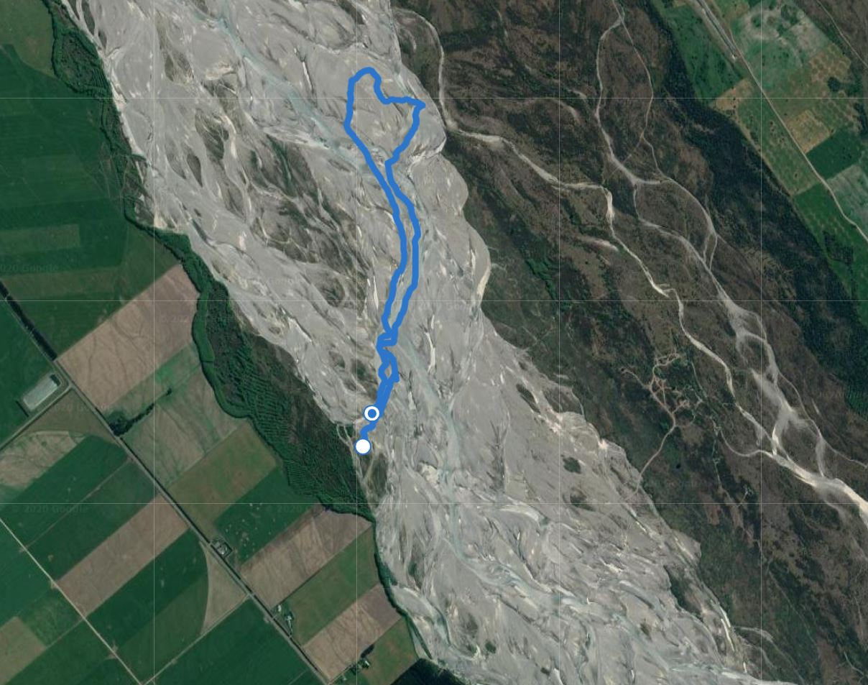
Checklist 1 survey track

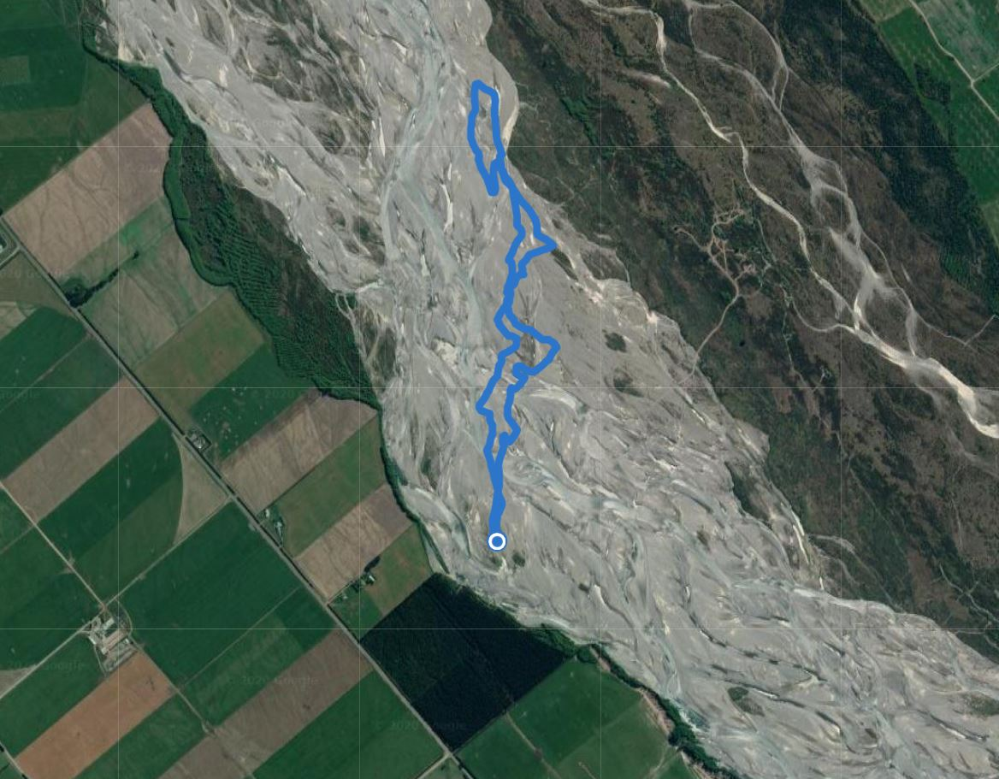
Checklist 2 survey track
Checklist 1
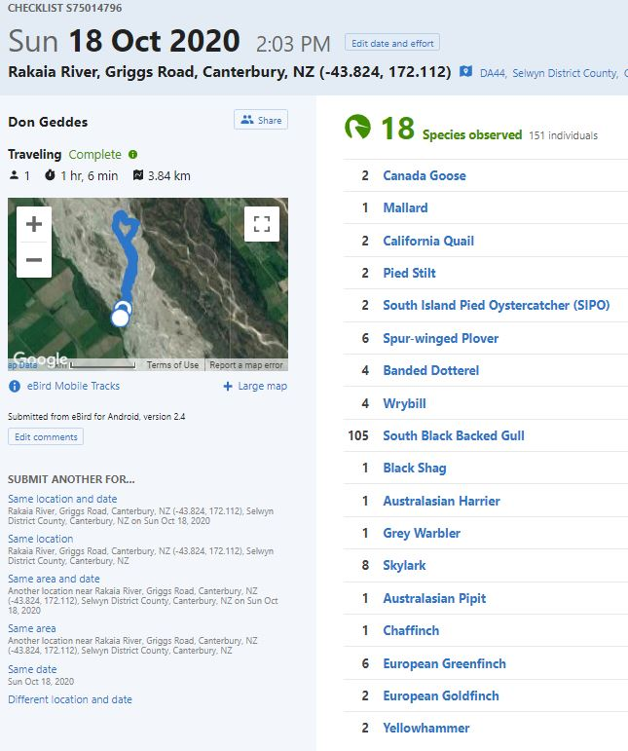

Checklist 2
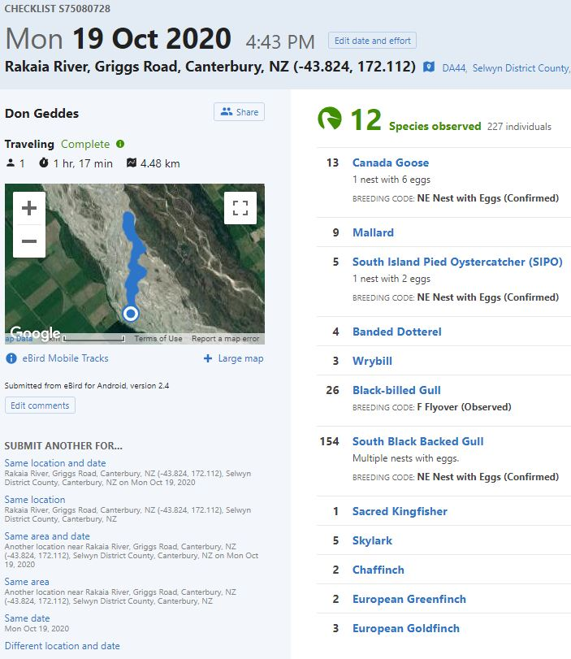
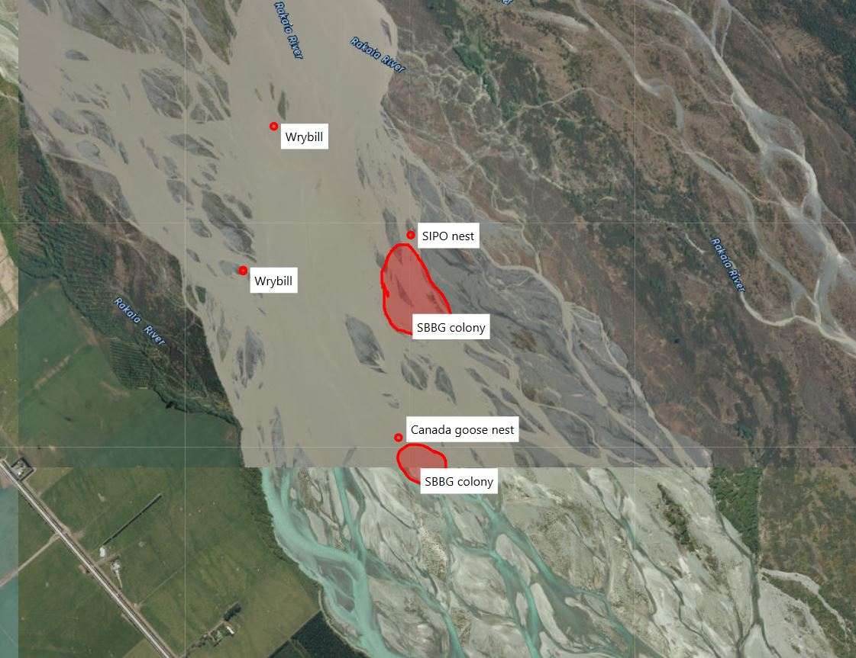
Bird locations

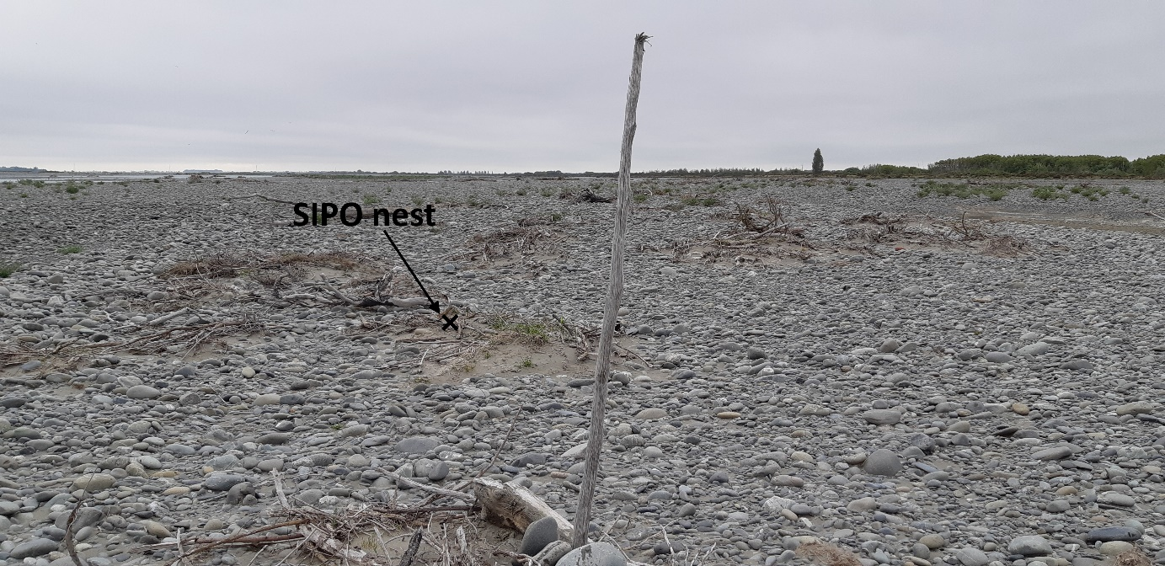
SIPO nest and marker stick – view North

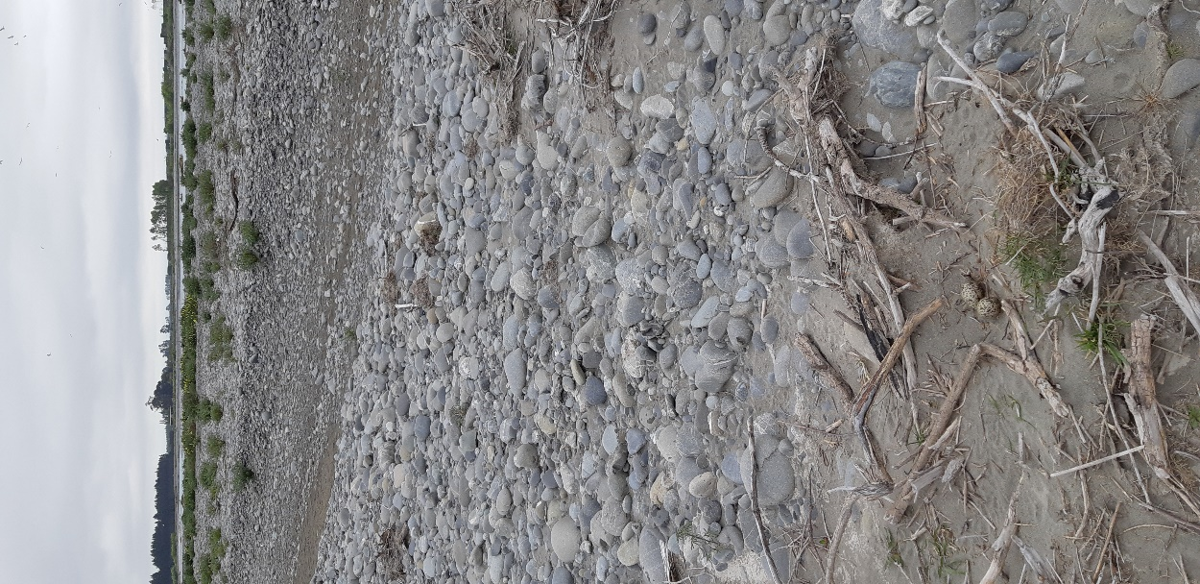 | 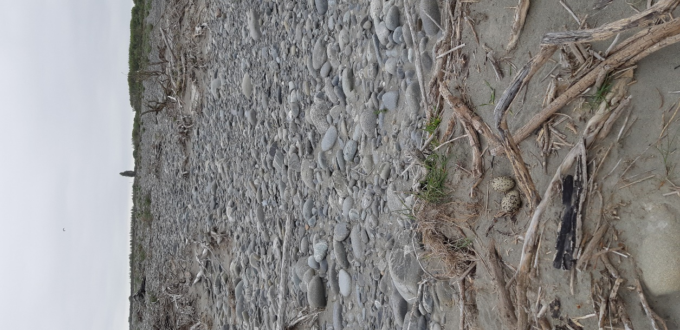
SIPO nest – view South | SIPO nest – view North
4 Discussion and Recommendations

The weather at the time of the survey on 18 October was fine and sunny with a light upstream wind, and temperature of about 12°C, providing good survey conditions.

The weather at the time of the survey on 19 October was overcast with a 10-15kph southerly wind, and temperature of about 12°C, providing reasonable survey conditions.

There was one large stable island that I was unable to access due to it being surrounded by large streams. This island is in the vicinity of the site identified as a source of shingle for the protection works. This island could be surveyed at a later date once the current river channels have been dewatered, and before any protection works begin.

Particular attention in checklist 2 was given to the margins of the two streams that branched off the main stream, and which are to be the focus for diverting the main river. These streams were checked on both sides for approx. 150m downstream of the point where they branch off the main stream.

It was clear that there had been a recent flood, as much of the riverbed adjacent to the existing streams has been swept with floodwaters. A check of the ECan website, river flows, shows a flood peaking at 803 cumecs occurred at Fighting Hill in the Rakaia River on 12 October 2020.

Several wrybill were located but only two of these were on the ground, and both were feeding on riffles at the waters edge. All the other wrybill were observed flying overhead and did not linger in the area.

A single banded dotterel was observed on the ground. Others were observed in flight, but were traveling and did not appear to be resident birds.

An occupied South Island Pied Oystercatcher nest with two eggs was located during the second survey, at approximately grid ref E1529182 N5147422. Unfortunately the GPS coordinates for this nest were not saved correctly, so the coordinates are an estimate only. This nest was marked with a 2m high stick from river driftwood, with the nest located 6m north of the marker. Photos attached. This nest is approx. half way between the two streams identified for diversion works, and is far enough away from the proposed works to not be an issue. Any disturbance at this nest would be only episodic, rather than continuous, and so I recommend a 50m exclusion zone around this nest.

A flock of black billed gulls flew over during the survey, but they had no interaction with the habitat below.

There are two South Black Backed Gull colonies within the survey area on the downstream side of the main stream, with multiple nests containing eggs, and a Canada goose nest (E1529147 N5146887) with six eggs on the edge of one of the gull colonies.

5 Recommendations
Works can proceed in the proposed extraction area without the need for any avoidance / mitigation measures other than maintaining a distance of 50m from the SIPO nest.

It would be worthwhile conducting a survey of the large island referenced earlier in this report once dewatering has occurred and access can be gained to that specific site.

