Pre-works Bird Survey | River Name: Rakaia, Griggs Road
Date: 20 & 22 November 2020
Time survey start & end:
20 Nov - 1619 hrs to 1840 hrs (2 checklists)
22 Nov - 1104 hrs to 1316 hrs

A report for: Matt Surman, ECan

1 Surveyor’s Qualifications and Experience:

The survey was undertaken by: Don Geddes

I have been undertaking braided river bird surveys every year since the 1970’s, and have surveyed most braided rivers in Canterbury, and also the Wairau in Marlborough. I have assisted in the coordination and conduct of annual surveys of the Ashburton River since 1981.

I participated in a banded dotterel migration survey in the 1980’s which was overseen by Dr Ray Pierce and ran for several years. The study required the location of nests, and trapping and banding of adult birds.

I have also participated in a population dynamics study of South Island Pied Oystercatchers (SIPO) with Paul Sagar, Marine Ecologist with NIWA, through the 1980’s and 1990’s, on farmland around Mayfield, Valetta and Ashburton Forks. This project ran for 15 years and also required the location of nests, trapping and banding adult birds, and subsequent weekly follow up through the duration of the breeding seasons.

I was engaged by John Craig from Green Inc Ltd in September 2011 to teach SIPO trapping techniques to Peter Langlands as part of the population dynamics work he was contracted to carry out in the upper Rangitata River on SIPO and wrybill under the supervision of local DOC staff. This work was funded as part of offset requirements relating to a proposed wind farm in the Waikato which is on the migratory flyway for wrybill and oystercatchers.

During the 2019-2020 summer I completed three braided river bird surveys for ECan, one each on the Selwyn, North Ashburton and South Ashburton Rivers.

Additional to this experience I have an interest in birds and bird photography and spend many days each year on Canterbury braided rivers observing and photographing local shorebirds.

2 Search Effort
A survey was carried out in the proposed works site (including 100m buffer zones) using standard survey methodology.

The North side of the main river channel (Selwyn District side) was surveyed on 20 Nov and, due to the first eBird checklist terminating prematurely, includes two checklists. The weather was fine, 20°C and Easterly wind gusting 20+kph.

The South side (Ashburton District side) was surveyed on 22 November. The weather was overcast, 12°C and a Southerly wind gusting to 35+kph.

Copies of all checklists are attached as part of this report.

All shingle banks suitable for wrybill nesting within the survey area, that were in close proximity to the proposed works, were walked with the aim of flushing any wrybill that may have been incubating there. None were found.

A small number of islands in mid stream were not accessible due to river flows, so were not surveyed. However these would constitute only a small amount of the total survey area, and they are mostly low lying and unlikely to be suitable as nesting sites.

The survey area length is approximately 2km, and approximately 120ha in area.

3 Results
Bird species  Any ‘Nationally Threatened’ or ‘At Risk’ | Nest, chick(s) or colony | (NZTM) E | (NZTM) N
SIPO | 1 chick | 1529169 | 5146500
SIPO | Agitated behaviour  (chicks present) | 1529398 | 5147247
Banded dotterel | Nest 3 eggs | 1528294 | 5147689

Nests, Chicks and Colonies
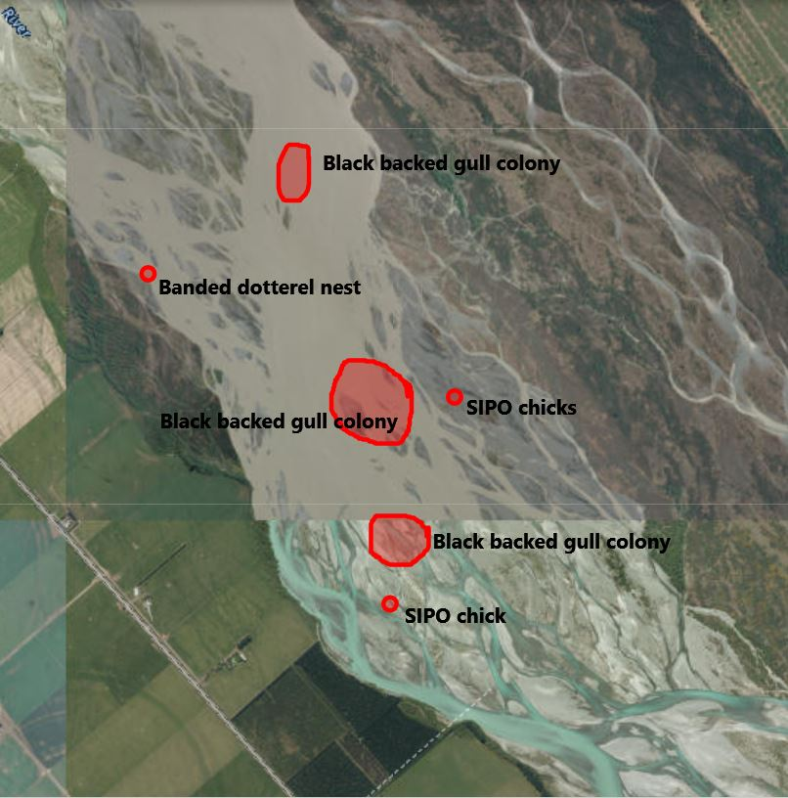

A complete checklist of all of the bird species identified during this survey, including species counts, location, date and search effort data has been submitted to the New Zealand eBird database and shared with the Environment Canterbury, NZ eBird account.

eBird checklist numbers
Upstream side of main river channel - Checklist number S76452980
Downstream side of main river channel - Checklist numbers S76452980, S76453031

South Island Pied Oystercatcher Chick
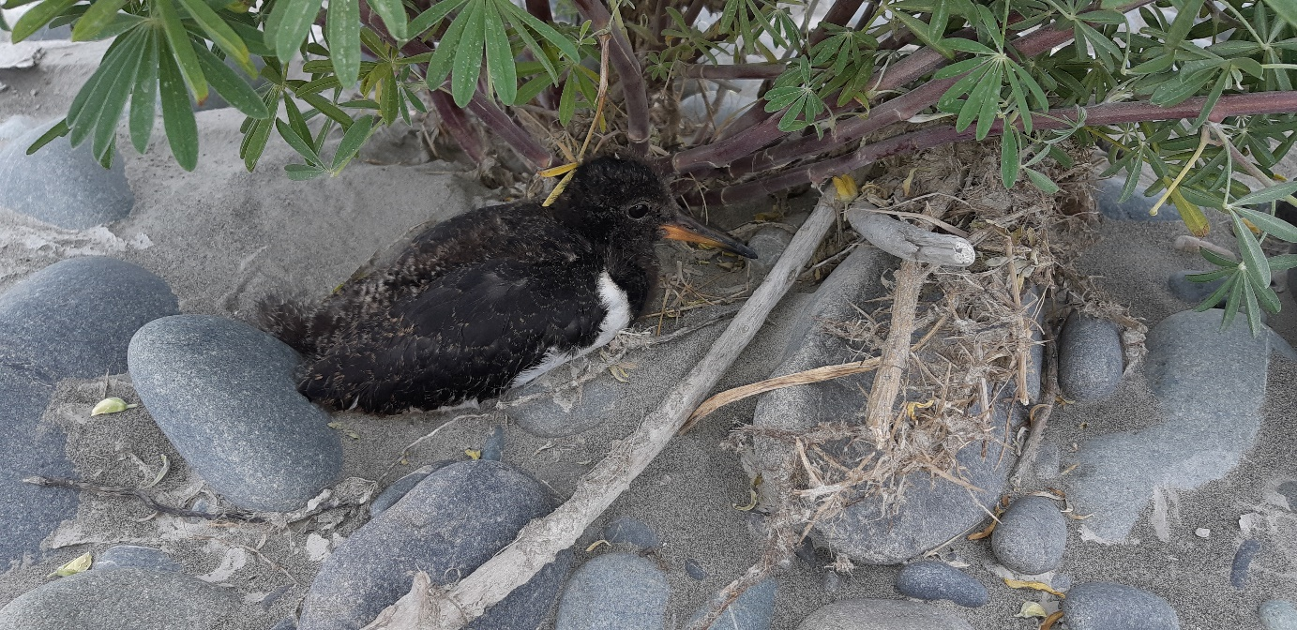

Banded Dotterel Nest – view looking downstream
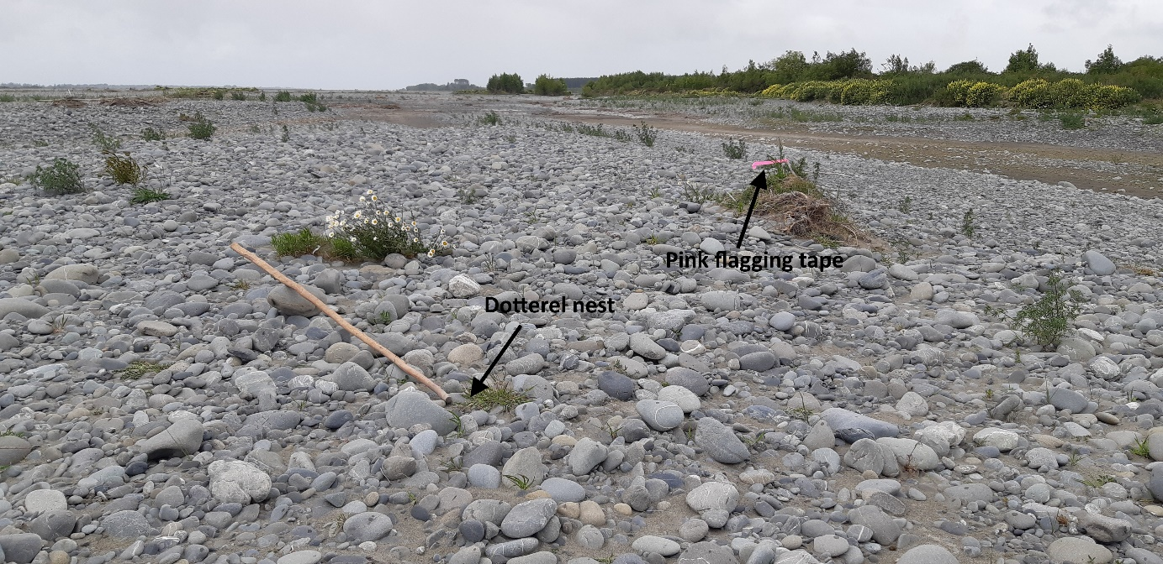

Banded dotterel nest
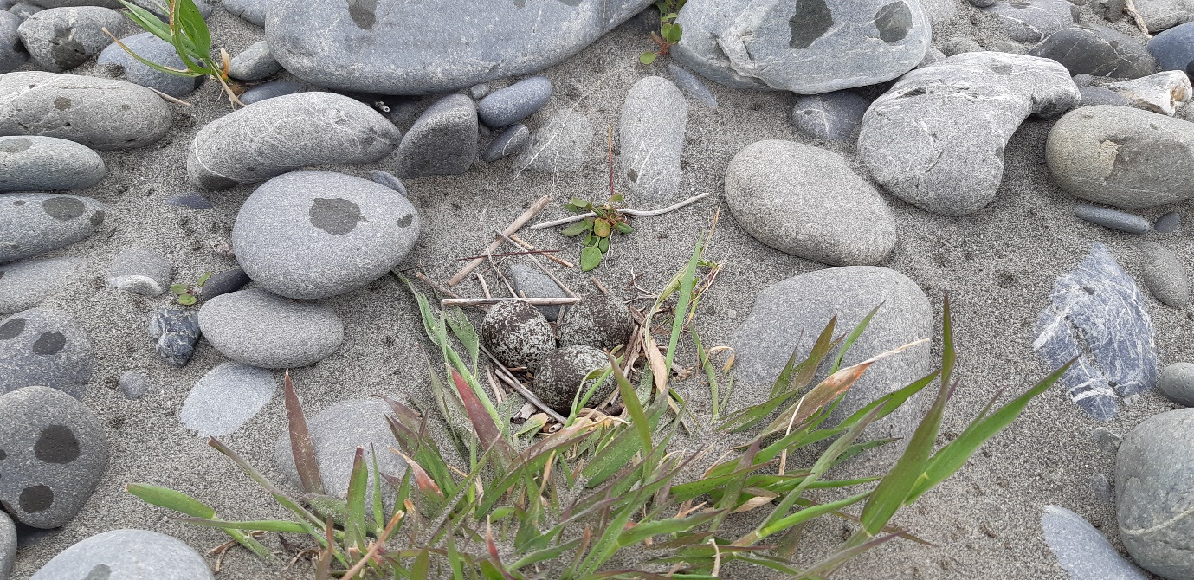

Checklist 1 survey track
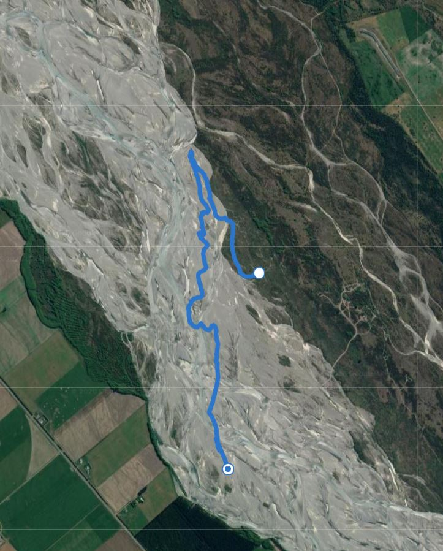

Checklist 2 survey track
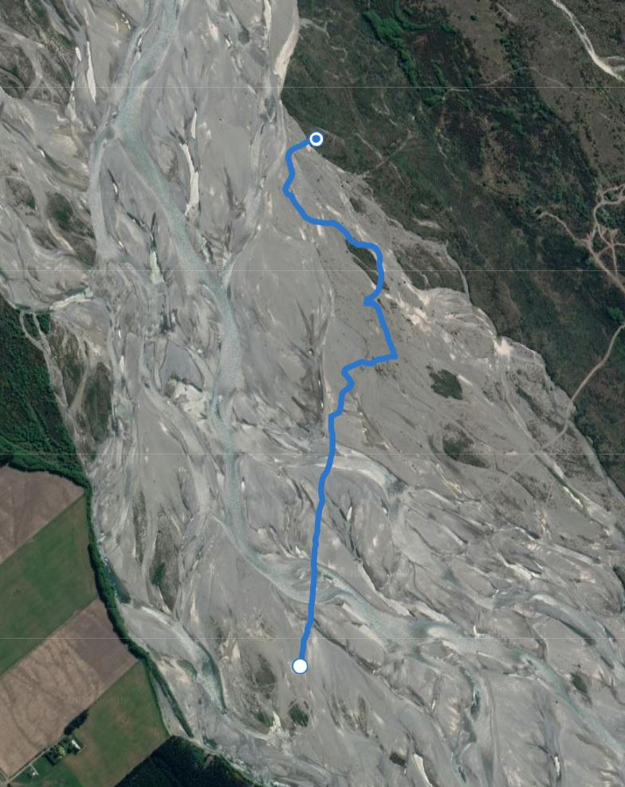
Checklist 3 Survey Track
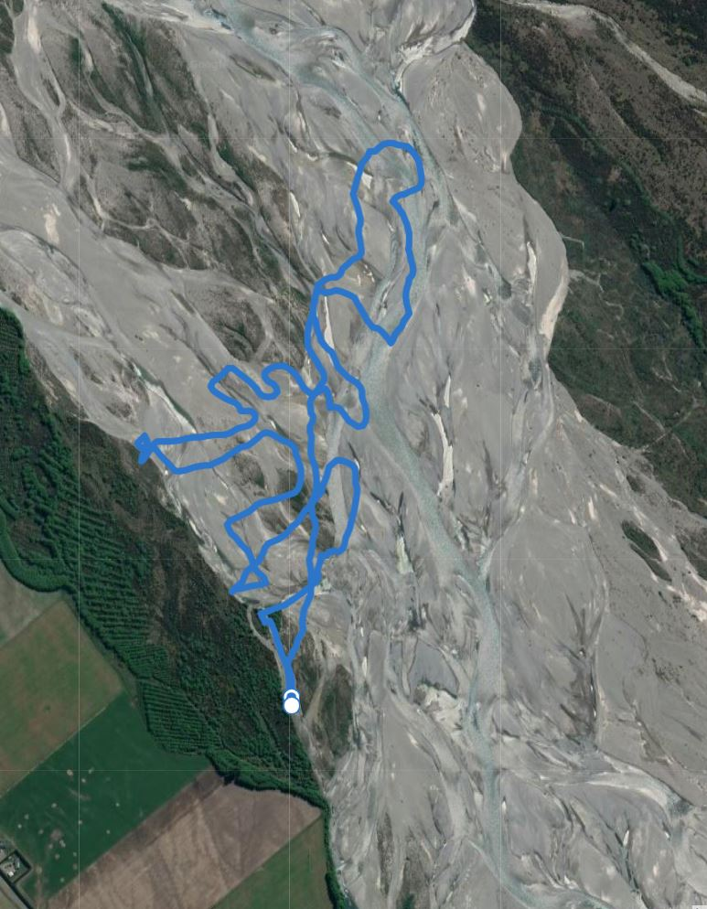

Checklist 1
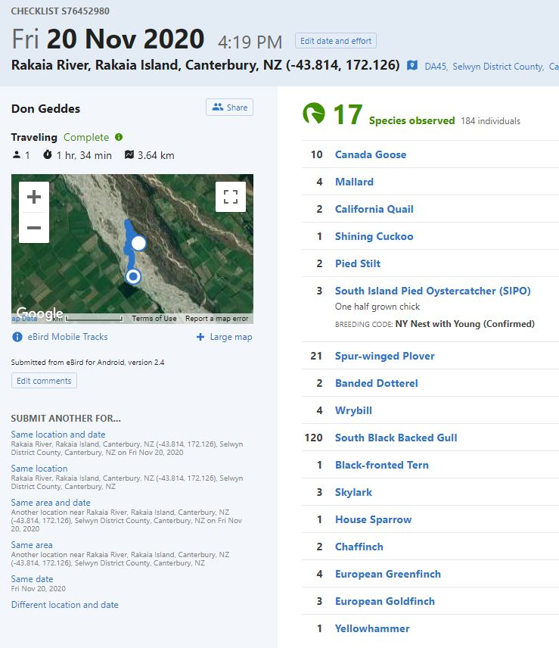

Checklist 2
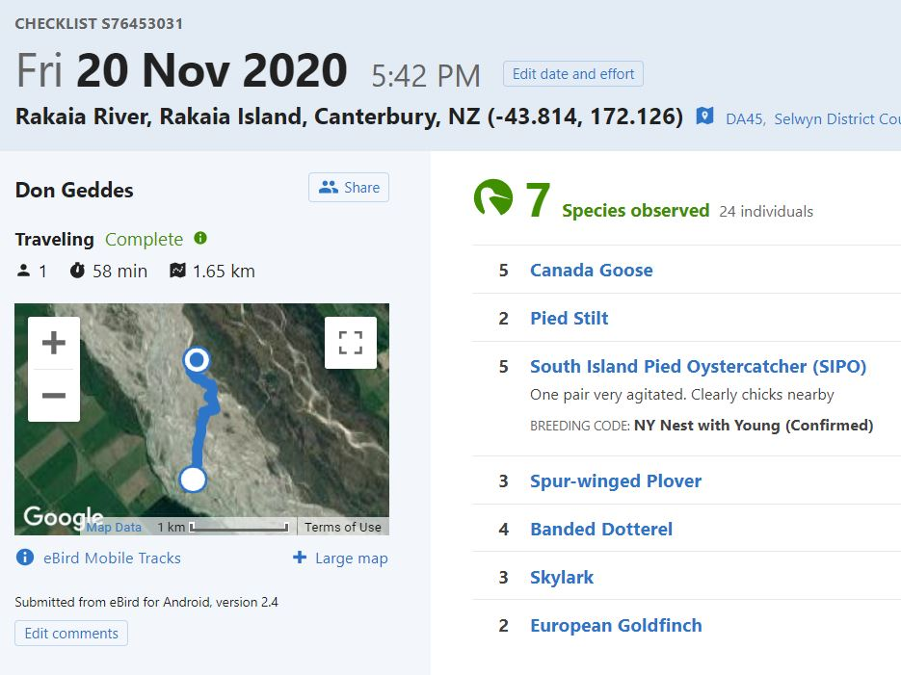

Checklist 3
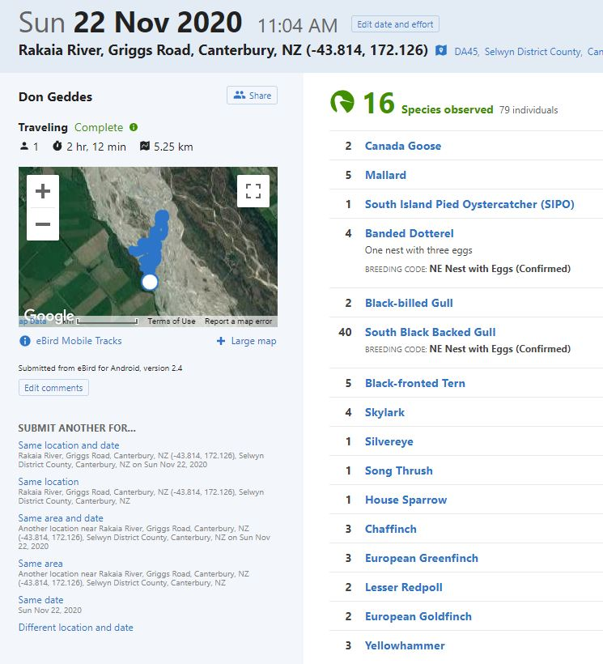

4 Discussion
Two breeding pairs of South Island pied oystercatchers were located. A well grown chick was located at one site, and the other pair were behaving in a very agitated manner, and clearly had chicks in the vicinity. These birds were only approx. 100m from the nest located during the survey on 18 October, and were most likely the same pair.

A banded dotterel nest was located at the extreme upstream end of the survey area on the True Right side of the riverbed. This nest was marked with pink flagging tape. The nest is 5m North of the tape.

Three black backed gull colonies are also located within the survey area.

All these sites are identified on the aerial photograph earlier in this report.

5 Recommendations
I recommend a 75m exclusion zone around the banded dotterel nest.

I also recommend a 75 m exclusion zone around each of the sites where the SIPO chicks were located, although they are usually quite mobile and may move from where they were located before any river works commence.

Subject to these avoidance / mitigation measures, I recommend that works can proceed in the proposed river works area.

