Invertebrate monitoring instructions for Ashley-Rakahuri Rivercare Group: November 2021 to February 2022

This project aims to identify the invertebrate diversity, abundance, and community composition of the Ashley River. Monitoring has occurred annually since November 2019. Three sampling lines are set up in a stretch of the river where no weed control is undertaken (‘weedy’ sites), and three in a stretch that has previously been cleared of weeds using a tractor towing a specifically designed ripper (‘raked’ sites). Since the last monitoring period a major flood altered the river therefore this summer we are looking more at the change in both sets of sites compared to pre-flood years.

Monitoring lines:
There are 6 sampling lines consisting of 1 Malaise trap and 5 pitfall traps. Lines 1-3 are accessed from the car park off the corner of Coldstream Rd and Marchmont Rd and Lines 4-6 are accessed from the carpark off Airport Rd at the end of Merton Rd (Figure 1). Traps were installed on October 28 and will be ‘opened’ for 5 nights in November, December, January, and February during a week of reasonably fine weather. Ideally, they should be opened on a Sunday and closed on a Friday to avoid vandalism. The site number (1,2,3,4,5,6) has been written on a rock at the base of each Malaise trap and the pitfall numbers (e.g. 1A, 1B etc) have been written on a rock and placed on the cover.
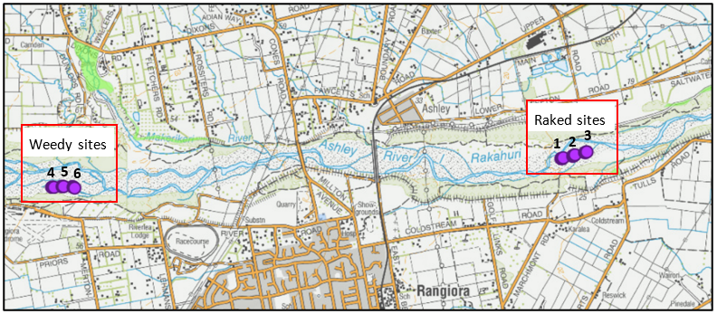
Figure 1: Locations of Lines 1-3 (Marchmont) and 4-6 (Airport).

Approximate sampling dates will be as follows to avoid holidays and weekends but we can be flexible around the weather and availability of helpers.
Session 1: 31 Oct - 5 Nov
Session 2: 5 - 10 December
Session 3: 9 – 14 January
Session 4: 13 - 18 February

Opening traps
Equipment: For each line you will need 1 x Malaise tent including screw-on collection bottle, zip ties, 5 x pitfall cups, 5 x pitfall covers (Black plastic), 15 x metal pitfall arms, glycol, specimen jar to measure glycol, trowels. Also take spare pitfall cups uncase any crack and scissors, spare string, duct tape to make malaise trap repairs if needed.

1) Attach the Malaise to the waratahs with the tall end up-river (Figure 2). Start by attaching the top of the tall end to the waratah/white fiberglass pole (used to add height) with a zip tie making sure the fabric is not twisted at the collection bottle. Secure the bottom of the tall end to the ground at the base of the waratah then repeat at the short end so that the base of black centre wall is reasonable tight between the two waratahs and touching the ground. Using rocks and ropes pin out the sides of the trap so the whole tent is reasonably taught. Place a few rocks on the ends of the side flaps and along one side of the centre wall fabric to keep reasonably good contact with the ground. Unscrew the collection bottle and pour about 40-50ml (~2/3rds of a specimen jar) of glycol into this then screw it back on to the malaise trap – the trap is now ‘open’ and insects that get into the trap will be caught and preserved in this fluid.

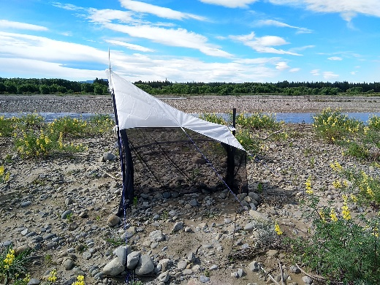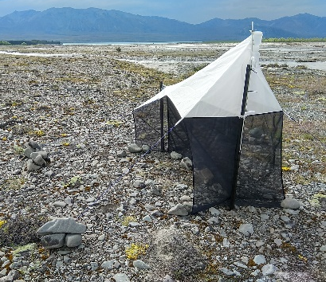
centre wall
short end
Tall end
Side flaps
Collection bottle
Figure 2: Properly installed Malaise trap with all flaps pinned out and collection bottle not twisted.

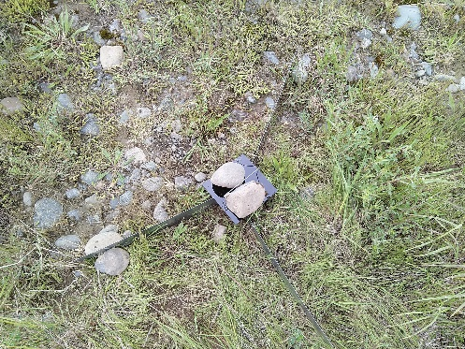
2) Install the pitfalls by re-digging the holes 6m apart. It might be possible to leave the cups in the ground between months but if not a stone with the trap number written on it will be left on top of the hole so, hopefully, they will be easy to re-dig. Ensure the lip of the cup is flush with or below ground level so insects can fall in. It is very important the lip is not sticking up above the ground. Gently scoop out any sand and stones that fall in. Place the 3 metal arms so the bent ends meet the edge of the cup and secure in place with one or two rocks on each side away from the cup (not all the way along, Figure 3). Pour in 40-50ml of glycol (~2/3rds of a specimen jar) and carefully place the black plastic rain cover on the metal arms with a rock on top. Your pitfall is now open! Repeat so there are 5 pitfalls in each line (30 total).

Closing traps
Traps are ‘closed’ (emptied) after 5 nights.
Equipment: 36+ specimen jars (6 for the malaise traps + 30 for the pitfalls + spares). Labels + spares. Scissors for cutting zip ties. String to tie pitfall arms together in batches. Bag or box to put malaise traps, pitfall covers and arms into. Blue lids (x6) for malaise collection bottles. Pitfall cup lids (x 30).
Labels: Before heading out write the date the traps were opened on the labels in pencil. I like to use a paper clip to clip together the 5 pitfall and 1 malaise label (i.e. Malaise 1, Pitfall 1A, 1B, 1C, 1D, 1E) that is needed for each line, so they are easy to find when needed.
Malaise: Unscrew the bottom collection bottle from the top part and pour contents into a specimen jar. Place correct Malaise label in the specimen jar with the fluid and insects. Put a blue lid on the collection bottle so it can be stored until next month without getting any remaining glycol on the malaise trap or in your car. Take the Malaise trap off the waratahs and carefully roll up with the ropes and sticks still attached so it will be ready to go next month – if damp these could be left to dry somewhere before rolling up. Leave the Waratahs in place.
Pitfalls: Pour the contents of each pitfall cup into a specimen jar and add the correct pitfall label (e.g. Pitfall 1A, 1B, 1C, 1D, 1E are the labels for line 1 – these have also been written on a rock on or by the pitfall trap). If there is too much fluid in a pitfall cup for one specimen jar use a second jar and a spare label with correct information written in pencil and note which trap number it is so we know they are the same trap.
Remove the 3 arms and rain covers – stacking and tying together all 15 arms from each line will ensure they are ready to go for next month and that the same sized arms stay together (they are not all cut exactly the same but work better if each of the 3 are roughly the same size). Store arms and covers in a box until next month. Cups can be left if the ground with a lid on and a rock on top if easy to do so, but if the holes collapse when collecting the specimens it may be just as easy to take them away and just place the labelled rock where the hole is for next time.

Transferring samples into ethanol

Equipment: Funnel, gauze, funnel stand, pitfall cup to collect glycol, teaspoon, wash bottle. 1 L bottle
Pour 700ml of ethanol into a 1L bottle and top up to 1L with cold water to make a ~70% solution. Attach gauze to funnel so it is quite tight then in a laundry sink pour glycol and insects from a specimen jar through the gauze and collect the glycol in a clean pitfall cup. Pour the used glycol into a bottle for future use. Rinse the specimens (still in the gauze) and the specimen jar with a little water the use the teaspoon to transfer the specimens back into the same jar with the same label. Pour in ~40ml or ethanol or enough to cover all the specimens. If they don’t fit in one jar use a second jar and a spare label with the correct information on it and note ‘1 or 2’, ‘2 of 2’ etc. Repeat for each specimen jar. You should end up with 36 specimen jars (6 malaise and 30 pitfalls) or more if there are any traps that require 2 jars.
Deliver samples to Sandy Yong at the Rangiora DOC office and email Tara tmurray@doc.govt.nz (or call on 027 285 6852) to let me know they are there, the day they went out and they day there were brought in. OR If anyone happens to be going into chch who could deliver them to the Cashel street DOC office they can be delivered to Ellery Mayence, but we would need to let him know in advance (again just call Tara).
Ethanol (flammable) and glycol should always be well labelled and stored somewhere cool away from children and pets etc. Both are safe to wash down the sink with plenty of water (e.g. rinsing pitfall cups) but I suggest the laundry rather than the kitchen. Ethanol should be used in a well ventilated area.

