BRaid – Minutes of General Meeting, Monday 22 June 2015

Time: 1pm
Location: Dept. of Conservation, Maahanui Area Office, 31 Nga Mahi Road, Sockburn
Map : https://www.google.co.nz/#q=31+Nga+Mahi+Road

Minutes written by Nick Ledgard
- Present. Sonny Whitelaw, Edith Smith, Nick Ledgard, Eleanor Bissell, Leslie Shand, Claudia Mischler, plus Gerry Cadby and Phyllis Collins (Waiau Rivercare, Blenhiem)

- Apologies. Geoff Swailes, Courtney Thompson, John Dowding, Jane Demeter, Jim Jolly (screen link with Geraldine not possible), Diana Shand, Annette Hamblett, Mark Sanders, Steve Attwood, Frances Schmeckel. Moved/seconded as accepted: Nick/Edith. Carried

- Presentation: Courtney Thompson had the ‘bug’ so her talk on last season’s bird management on Waimakariri river was postponed until the next meeting

- Minutes of previous meeting 13 April 2015. Moved/seconded as a true and correct record: Edith/Sonny. Carried
- Matters arising
  - ECan Gravel extraction Code of Practice. BRaid has submitted to this, and the matter was well covered at the last meeting. COP now nearing completion. Leslie S commented that ECan staff on rivers as part of their job during the bird breeding season need to be well aware of the birds.
  - ECan Braided River Regional Initiative. Involves a number of bird-related activities, which were well covered in last minutes. On-going.
  - Upper Waimakariri survey report. Jim Jolly is completing this report. Action Item: Jim must complete this report asap.
  - NEXT Foundation update. New application round open, but meeting felt that BRaid should still wait before applying – especially as one is only allowed a single application ie., if not successful, cannot apply again.
  - Braided river tourism. This remains an under-utilised opportunity to improve awareness. The CCPF application (see below) intends to contact commercial tourism operators.
  - Gull nesting on L. Henley island, Wairarapa. Nick has been in contact, and reported that, although nesting was not successful last season (competition from Canada geese and rats), attempts to overcome these problems (fencing and trapping) will be tried next season.
  - Protocol for seasonal management/monitoring of bird colonies. Protocol proposal outlined in last minutes. The intention is that we recommend a course of action once breeding birds (particularly colonies) are located - from noting location, to further monitoring and possibly management (trapping). Action item: Working group of Edith (leader), Jan, Richard, Philip, Colleen and Jane to draft a protocol for consideration before the next breeding season.
  - Lupin letter. Concern about potential for Russell lupins (being used as a farm forage crop) escaping to become a weed in currently uninfested waterways. Action Item: Nick to contact Frances S to see how best for BRaid to act. Perhaps write a letter to the Canterbury/Aoraki Conservation Board.
  - Kakapo brook consent application. BRaid has registered an interest in this consent application. Gerry C commented that when minimum flow thresholds are set, these need to be publicly notified, and checks made that they are being monitored appropriately.

- Correspondence
In
  - ARRG letter of support for Community Conservation Partnership Fund (CCPF) application by BRaid
  - Waiau Rivercare Group letter of support for CCPF
  - LINZ letter of support for CCPF

  - Jet Stream Tours NZ Ltd expression of interest for CCPF

  - Response from ECan re SOL gravel extraction.

Out:
- ECan re SOL gravel extraction. Nick reported that SOL are under close scrutiny by ECan for abusing consent conditions.

- Financial statement.
Presented and accepted. Moved/seconded: Edith/ Eleanor. Carried. Currently in a healthy state, with $3,269.87 as uncommitted funds. Remaining funds ($18,557.51) committed to Manager’s payment. An invoice for $6,955.76 later received from Manager for contractual duties undertaken to date.

- Membership: 37 current members. Still a few 2015 subscriptions to be received.

- Manager’s report:
  - Website, social media, and e-newsletter. Sonny outlined how she has spent most of her time to date setting up the website and social media outlets. The framework is now largely complete, but she needs help to ‘populate’ the site. Will train a couple of members to assist her with that.
  - Kite boarding Ashley estuary. This meeting to decide how kite surfers might use the estuary with minimal disturbance for birds was held on June 9. It appears that a good compromise agreement should be reached. Steve Attwood to act for us as the ‘bird’ spokesman.
- Monitoring: Sonny will set up a framework for recording monitoring data. May be aligned with Naturewatch.
- General business:
  - DOC’s braided river practitioners workshop, Geraldine, April 28-29. Report by Sonny and Nick who attended the meeting. BRaid working in close relationship with DOC and its Braided River Technical Action Group.
  - Canterbury Community Partnership Fund (CCPF) application. BRaid has submitted an application aimed at increasing the awareness and potential management actions (monitoring and possibly trapping) by commercial users of braided rivers (eg., jet boat and rafting operators, fishing guides etc). Successful CCPF applicants should be known by September/October.

  - Submissions. Were made to the following
    - ECan Long Term Plan 10 April
    - ECAN Rivers Global consent (1043) 14 April
    - Kakapo Brook Hydro Project consent 28 April
    - Proposed Northern Pegasus Bay Bylaw 2015 12 Mar
  - 2015 training courses. The following three course options were discussed:
    - A half-day course on braided river bird background and potential management - aimed at Zone Committee members.
    - A full-day course on braided river bird management ie., a condensed version of the successful 3-day courses offered in previous years - aimed at the general public.
    - A half-day (possibly weekend) course on trapping. This could be jointly organized by ARRG and BRaid, and may well be offered in more than one venue. Aimed at all the people and groups involved in this activity. Action Item: Nick and Sonny to meet with John Dowding to determine details.
  - New Wairau rivercare group (Blenheim). Gerry C outlined the past history of attempts to manage and research birds on the Wairau. Much of this was under the auspices of the ‘Save the Wairau’ group, and the matter became very political with ‘we’ and ‘they’ attitudes prevalent. In order to avoid this problem it is proposed that a new Wairau Rivercare Group be started, with bird protection and management as its prime aim. Gerry also described the predator problems on the Wairau – these appear to be more serious, and will require more attention, than on some other rivers, such as the Ashley. Action Item: Phyllis C and Gerry C to set up an inaugural meeting (probably in Blenheim Council chambers) of interested parties, which would involve a BRaid presentation to outline work of such groups further south.
NB. One consequence of Gerry’s input to the meeting was to make BRaid (and ARRG) more aware of the need to try for greater involvement by local iwi and Fish and Game, who are noticeably absent from both Groups’ current makeup. Action Item: Nick and Sonny to seek greater involvement of iwi and Fish and Game in BRaid and ARRG.
- Date for Next Meeting (AGM): 1.00pm September 7, same venue (booked). AGM. Action Item: Sonny to advertise AGM in Press one month prior.
- Close of Meeting: 3.45pm
Signed: Chairman: Manager:
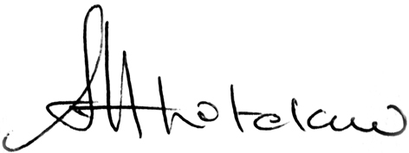
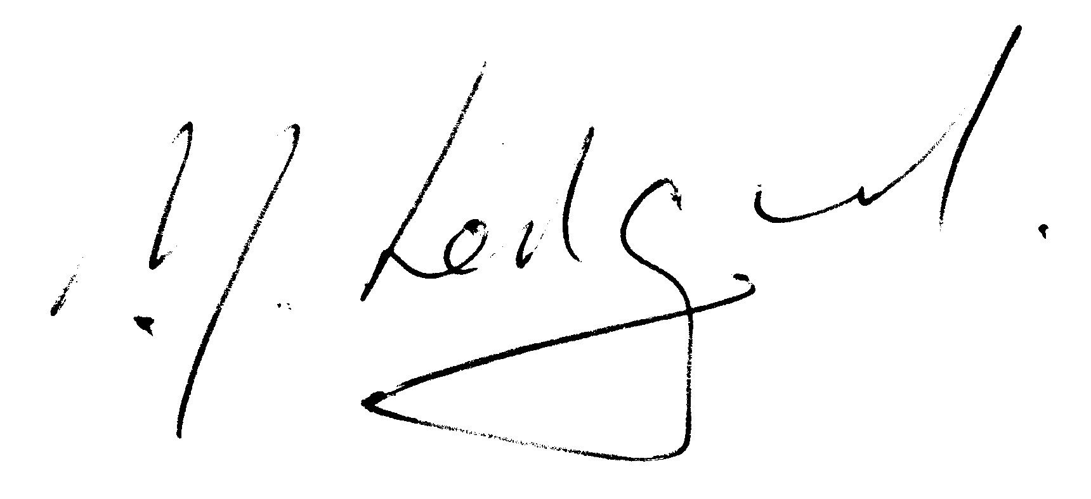
Date: 26 June 2015

