Pre-works Bird Survey | River Name: North Ashburton, Digbys Bridge
Date: 19 September 2020
Time survey start & end: 0809hrs to 0852hrs
A report for: Ryan Dynes, ECan, resource consent code ?

1 Surveyor’s Qualifications and Experience:

The survey was undertaken by: Don Geddes

I have been undertaking braided river bird surveys every year since the 1970’s, and have surveyed most braided rivers in Canterbury, and also the Wairau in Marlborough. I have assisted in the coordination and conduct of annual surveys of the Ashburton River since 1981.

I participated in a banded dotterel migration survey in the 1980’s which was overseen by Dr Ray Pierce and ran for several years. The study required the location of nests, and trapping and banding of adult birds.

I have also participated in a population dynamics study of South Island Pied Oystercatchers (SIPO) with Paul Sagar, Marine Ecologist with NIWA, through the 1980’s and 1990’s, on farmland around Mayfield, Valetta and Ashburton Forks. This project ran for 15 years and also required the location of nests, trapping and banding adult birds, and subsequent weekly follow up through the duration of the breeding seasons.

I was engaged by John Craig from Green Inc Ltd in September 2011 to teach SIPO trapping techniques to Peter Langlands as part of the population dynamics work he was contracted to carry out in the upper Rangitata River on SIPO and wrybill under the supervision of local DOC staff. This work was funded as part of offset requirements relating to a proposed wind farm in the Waikato which is on the migratory flyway for wrybill and oystercatchers.

During the 2019-2020 summer I completed three braided river bird surveys for ECan, one each on the Selwyn, North Ashburton and South Ashburton Rivers.

Additional to this experience I have an interest in birds and bird photography and spend many days each year on Canterbury braided rivers observing and photographing local shorebirds.

2 Search Effort
A survey was carried out in the proposed works site (including 100m buffer zones) using the standard survey methodology provided by Environment Canterbury

The area surveyed was within the grid references:

- E1497910 N5144329
- E1497955 N5144342
- E1497887 N5143519
- E1497982 N5143511

The survey area length was 1860 m and was approximately 6.9 ha in area.

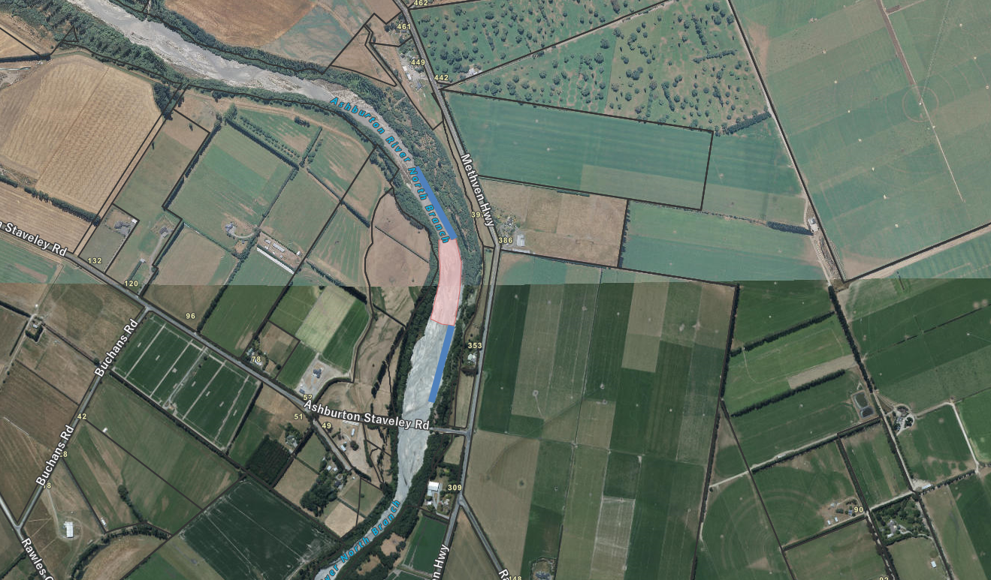
Shingle extraction area – map supplied

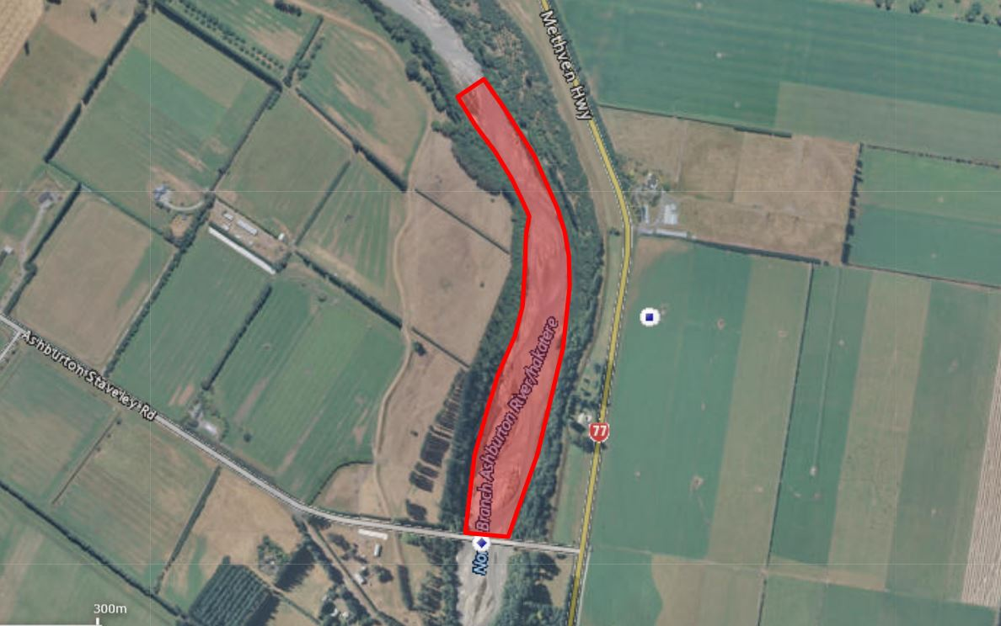 Surveyed area
3 Results
Bird species  Any ‘Nationally Threatened’ or ‘At Risk’ | Nest, chick(s) or colony | (NZTM) E | (NZTM) N
E.g. Banded dotterel | Nest (3 eggs) | E1557844 | N5190014
No species breeding
A complete checklist of all of the bird species identified during this survey, including species counts, location, date and search effort data has been submitted to the New Zealand eBird database and shared with the Environment Canterbury, NZ eBird account.

[ eBird checklist number S73752439].

4 Discussion and Recommendations

The weather at the time of the survey was partly cloudy with no wind, and temperature of about 7-10°C, providing good survey conditions.

The entire fairway of the river was surveyed from Digbys Bridge to a point approximately 1800m upstream. This is the upper limit of the disturbance area identified on the ECan supplied map.

Only one species that is classified in either the ‘Nationally Threatened’ or ‘At Risk’ categories was located, and these birds (a single flock of black billed gulls) were recorded in the eBird checklist as ‘flyover’. None of these birds had any interaction with the habitat.

With the exception of a pair of pied stilts, which were showing no territorial or breeding behaviour, I am confident that there were no other birds of any of the species listed in ECan’s support document ‘Field Bird ID sheets for persons undertaking works in the river’ present at this site at the time of the survey

5 Recommendations
Works can proceed in the proposed extraction area without the need for any avoidance / mitigation measures.

Images:

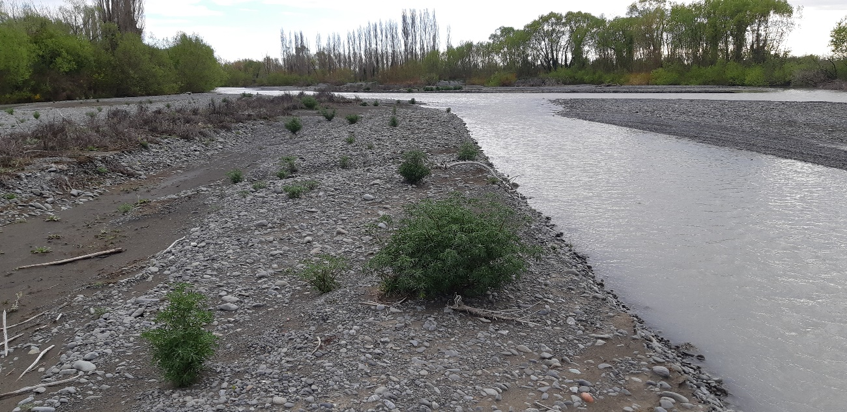
View upstream from lower end of shingle extraction area

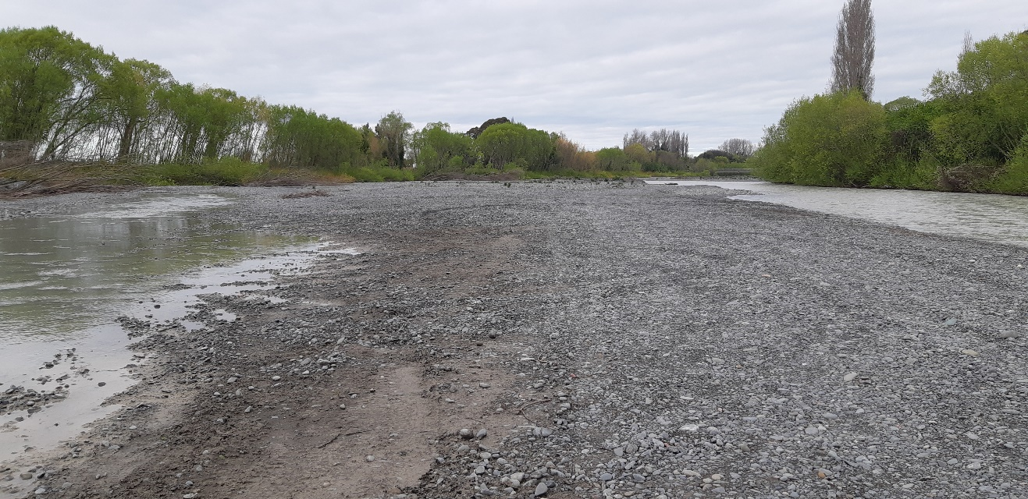
View downstream showing access to shingle extraction area from bridge

