Pre-works Bird Survey | River Name: South Ashburton – Walkhams Road
Date: 24.10.2020
Time survey start & end: 0818hrs to 1221hrs
A report for: Ryan Dynes, ECan

1 Surveyor’s Qualifications and Experience:

The survey was undertaken by: Don Geddes

Brief description of relevant experience, including:
-a summary of previous experience locating and monitoring shorebird nests
-a summary of previous experience carrying our shorebird census counts on rivers

I have been undertaking braided river bird surveys every year since the 1970’s, and have surveyed most braided rivers in Canterbury, and also the Wairau in Marlborough. I have assisted in the coordination and conduct of annual surveys of the Ashburton River since 1981.

I participated in a banded dotterel migration survey in the 1980’s which was overseen by Dr Ray Pierce and ran for several years. The study required the location of nests, and trapping and banding of adult birds.

I have also participated in a population dynamics study of South Island Pied Oystercatchers (SIPO) with Paul Sagar, Marine Ecologist with NIWA, through the 1980’s and 1990’s, on farmland around Mayfield, Valetta and Ashburton Forks. This project ran for 15 years and also required the location of nests, trapping and banding adult birds, and subsequent weekly follow up through the duration of the breeding seasons.

I was engaged by John Craig from Green Inc Ltd in September 2011 to teach SIPO trapping techniques to Peter Langlands as part of the population dynamics work he was contracted to carry out in the upper Rangitata River on SIPO and wrybill under the supervision of local DOC staff. This work was funded as part of offset requirements relating to a proposed wind farm in the Waikato which is on the migratory flyway for wrybill and oystercatchers.

During the 2019-2020 summer I completed three braided river bird surveys for ECan, one each on the Selwyn, North Ashburton and South Ashburton Rivers.

Additional to this experience I have an interest in birds and bird photography and spend many days each year on Canterbury braided rivers observing and photographing local shorebirds.

2 Search Effort
A survey was carried out in the proposed works site (including 100m buffer zones) using the standard survey methodology provided by Environment Canterbury

The area surveyed commenced at the Walkhams Road crossing and extended for 2kms upstream to a point E1487580 N5152024, and included the entire fairway width.

The survey area length was 2km and was approximately 38 ha in area.

3 Results
Significant bird species | Nest, chick(s) or colony | (NZTM) E | (NZTM) N
Black fronted tern | Colony (36 birds) | E1487959 | N5151808
Black fronted dotterel | Nest (2 eggs) | E1488420 | N5151397
Pied stilt | Nest (3 eggs) | E1487885 | N5151860

Survey Track
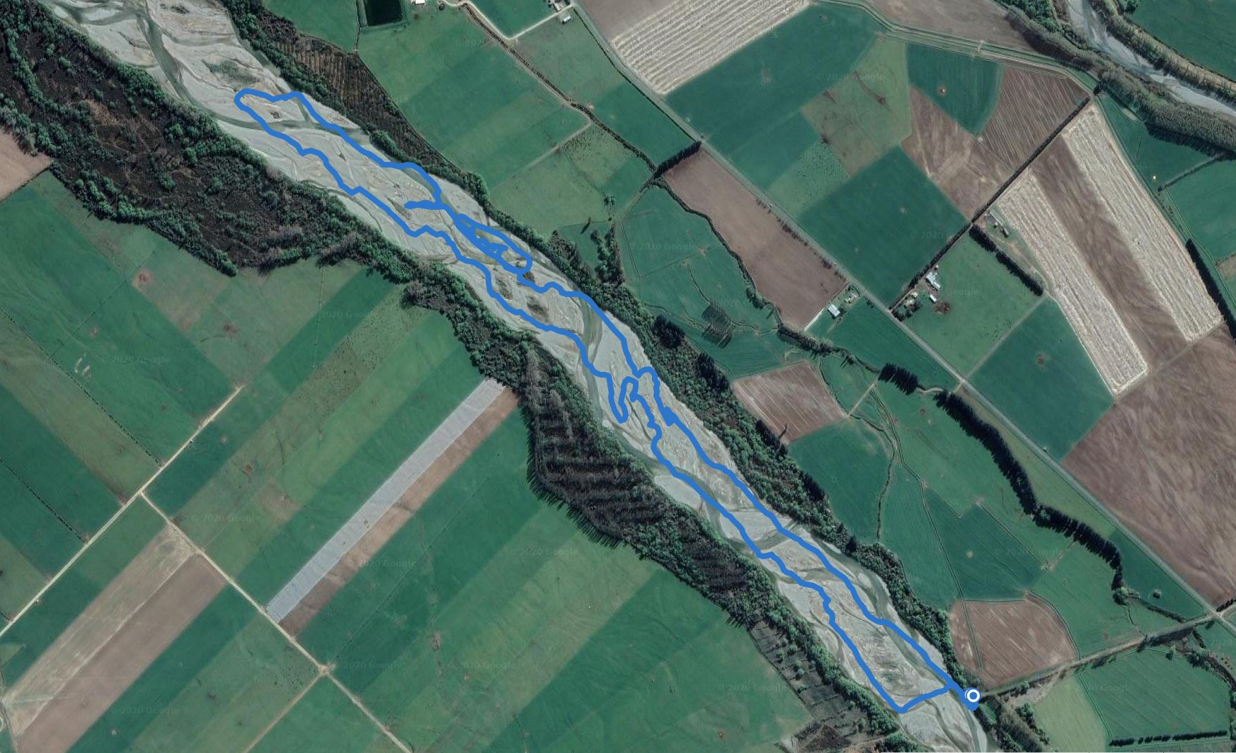

Locations of nests and colonies
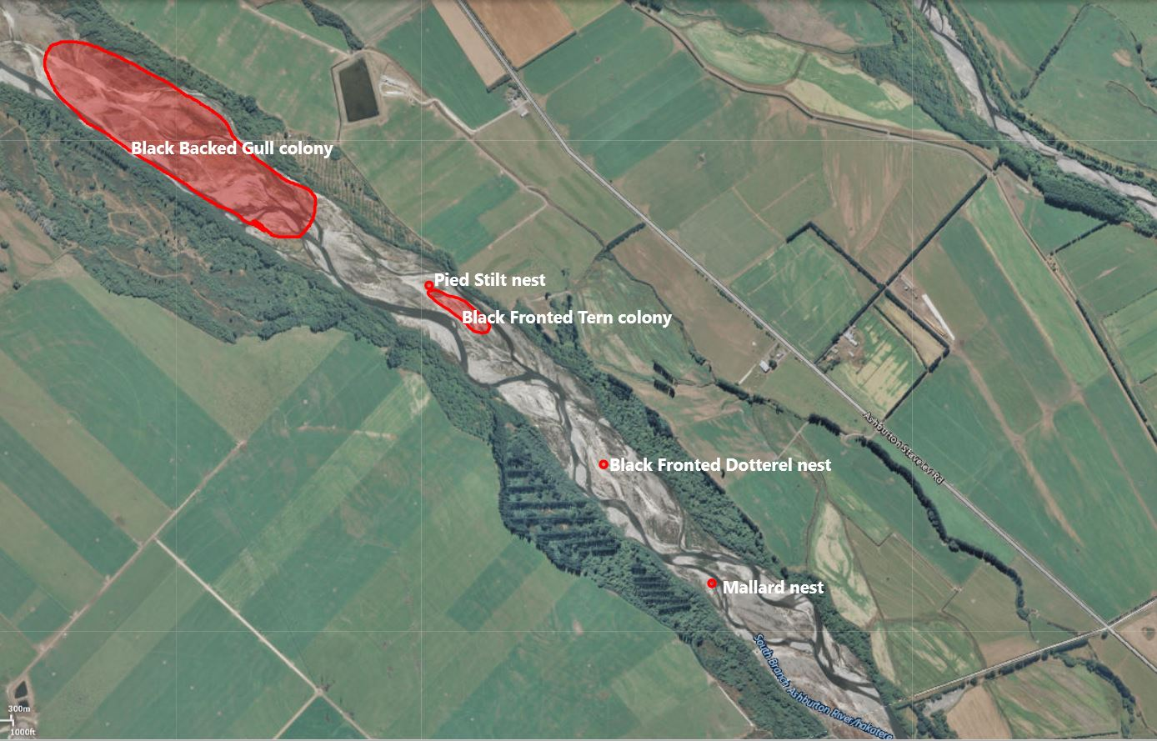

Survey Checklist
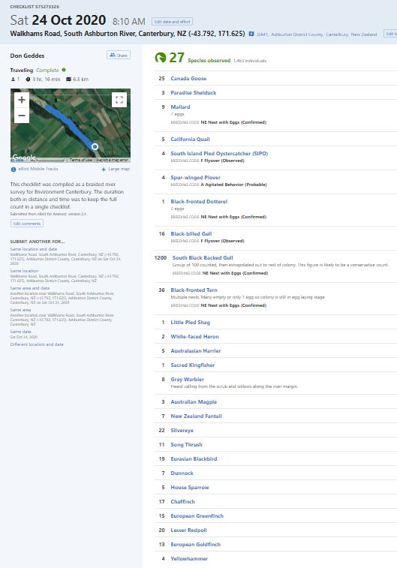
4 Discussion and Recommendations
The weather was fine and calm, with temp ranging from 12°C at the start of the survey, and rising to 23°C by the conclusion.

Much of the river bed is overgrown with lupins, broom and willow, but there are still many clearer sections suitable for shorebirds, gulls and terns.

A black fronted tern colony was located at E1487959 N5151808. 36 terns were counted here, and multiple nests located. Several nests were empty and others contained only one egg, indicating that the colony is in the early stages of establishment with egg laying still underway. Black fronted terns are very prone to disturbance at this stage of colony development, and can desert the entire colony if subject to too much disturbance. The perimeter of this colony is marked on the checklist survey track as an oval.

A large black backed gull colony was located at the very upper limit of the survey area and continued further upstream. A rough estimate of 1200+ birds was made for this colony. The furthest downstream nest at this colony was at E1487561 N5151995.

A black fronted dotterel nest was located. The nest was marked with a stone cairn, with a stick of driftwood standing up in the centre of it. This cairn was placed 4m to the South of the nest. Black fronted dotterels (both birds and nests) are very cryptic, and are often overlooked while breeding. This nest contained two eggs. I recommend a 50 m exclusion zone around this nest if the disturbance is only episodic.

A pied stilt nest with 3 eggs was located at the upstream limit of the black fronted tern colony. The normal clutch size for pied stilts is four eggs, so it is likely that these birds are still in the egg laying stage. No special exclusion requirements will be needed for this nest as it will be incorporated within the black fronted tern exclusion requirements.

The agitated behaviour of a pair of spur winged plovers on the edge of the black fronted tern colony indicates they are most likely to have chicks in the vicinity.

Worthy of note, and of some concern, was the complete absence of banded dotterel and South Island pied oystercatcher (SIPO) in the surveyed section of the river. No banded dotterels were observed at all, and the only SIPO observed were flyovers.

Recommendations
Works can proceed in the proposed works area subject to compliance with all the recommendations below relating to exclusions zones and avoidance/mitigation measures.

If access to the works site must pass the black fronted tern colony it is recommended that all vehicles stay as far as possible to the true right side of the riverbed until well clear of the colony. I also recommend not commencing any works for at least two weeks from the date of the survey to allow for egg laying to be completed and the birds to become more settled in the colony, and therefore less affected by disturbance.

The exclusion zone for the terns will also cover the pied stilt nest at the upper end of the tern colony.

An exclusion zone of 50m should be observed around the black fronted dotterel nest if the disturbance is only episodic.

Black fronted dotterel nest showing marker
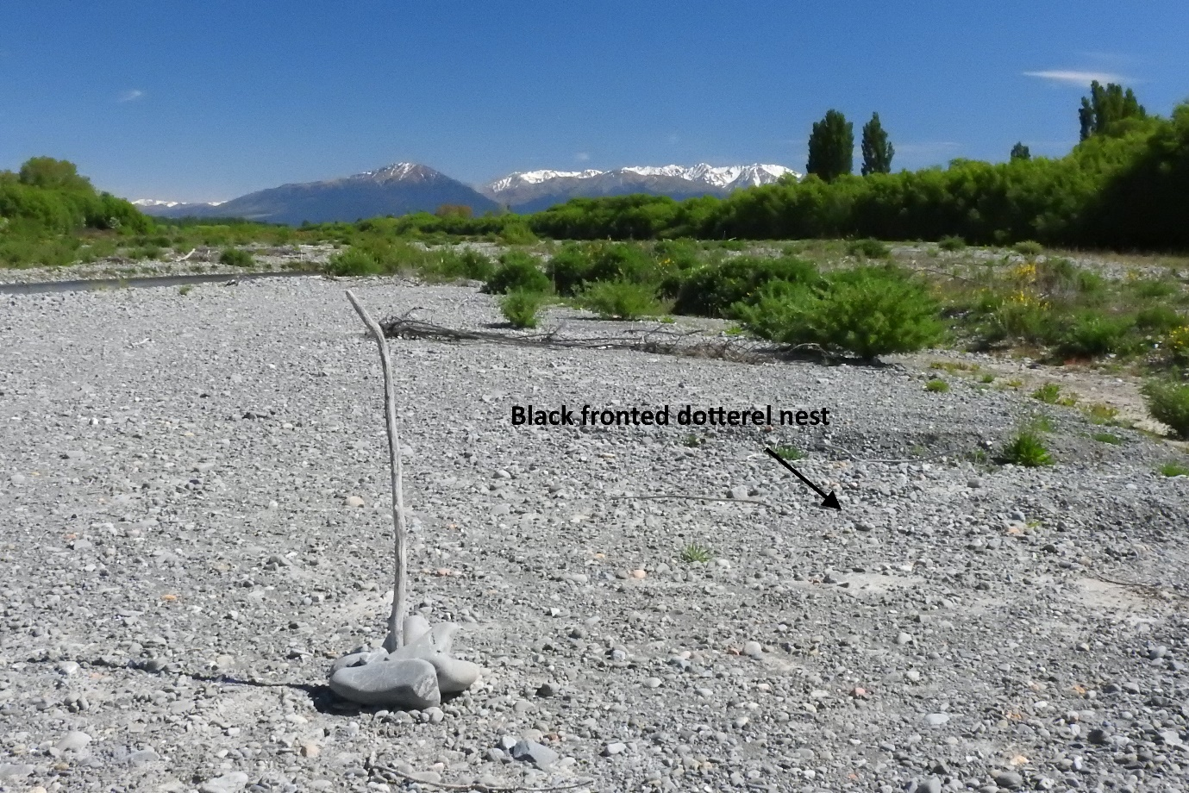

Black fronted dotterel nest
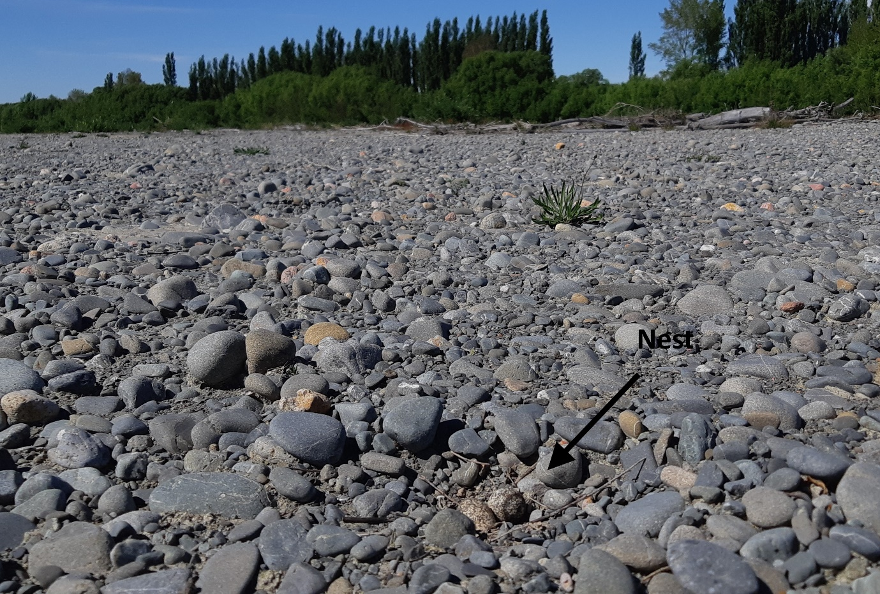

View of the black fronted tern colony island – looking downstream from the upper colony limit
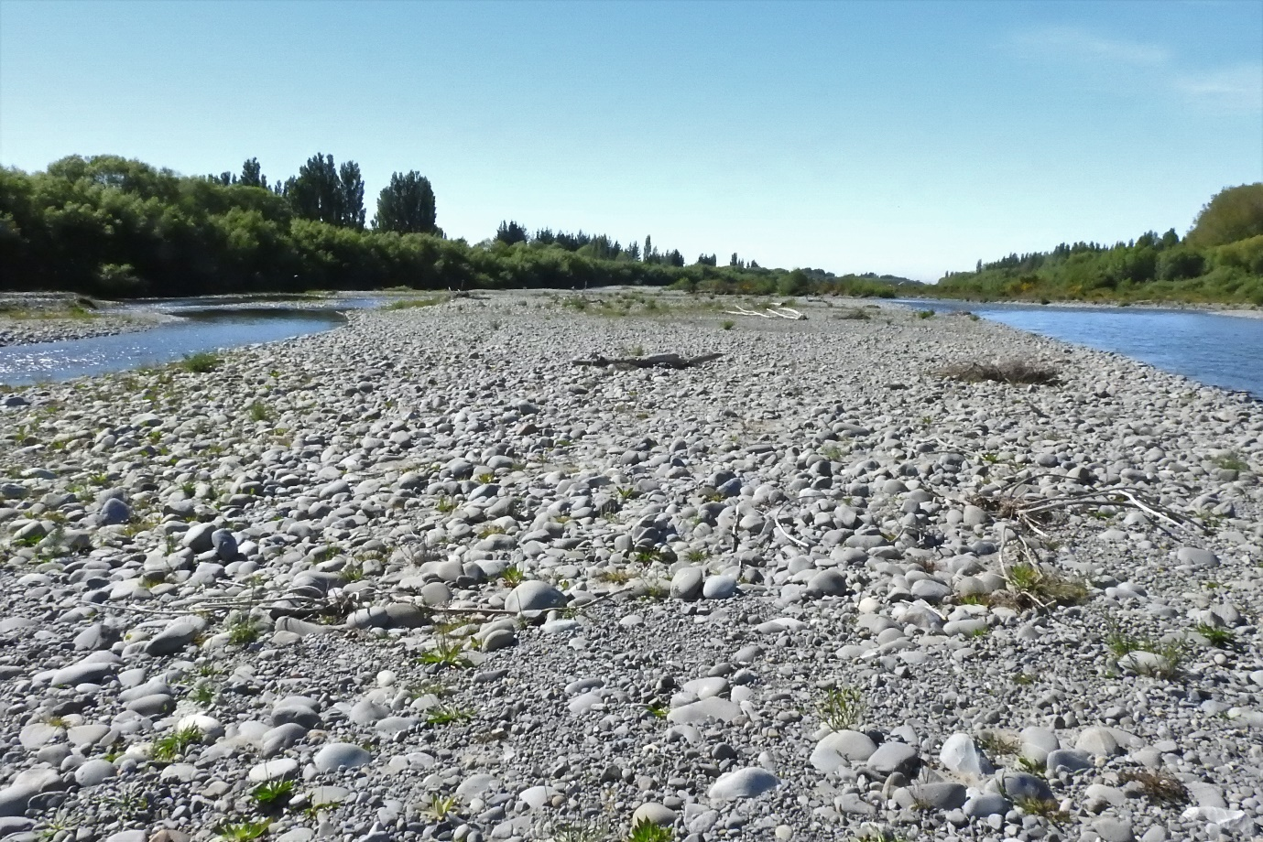

Part of the black backed gull colony
