Waimakariri River Regional Park 2014-2015 Black-billed Gull Breeding Season

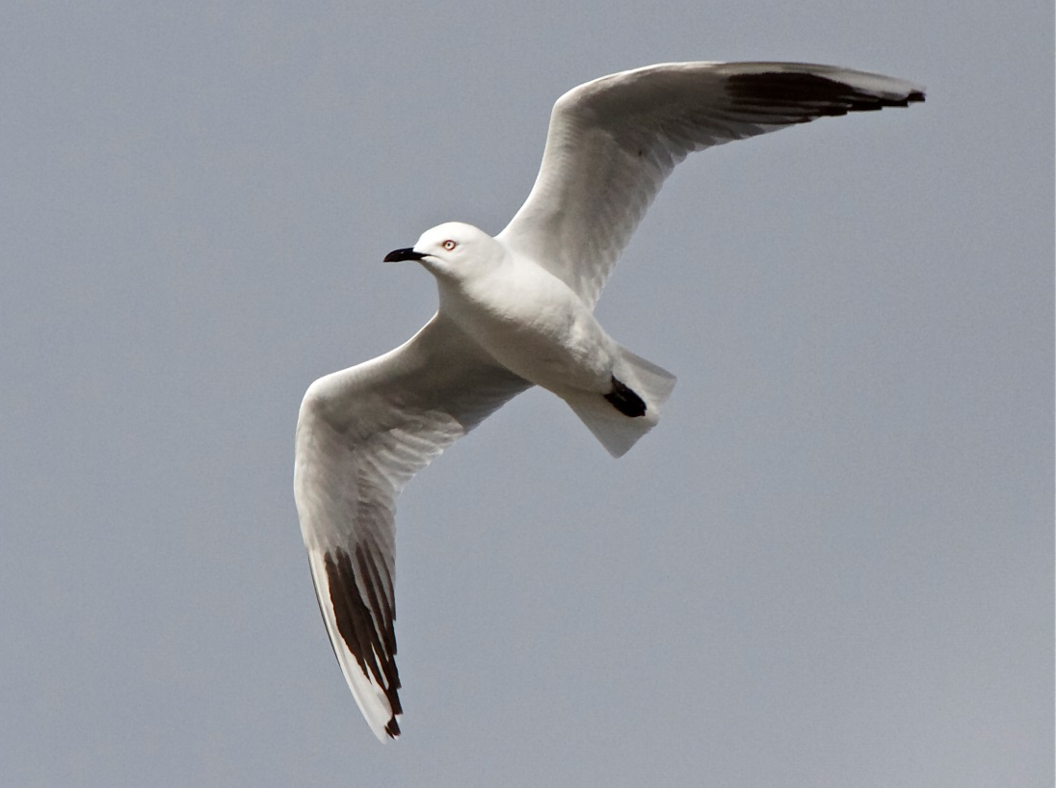
Photo © Steve Attwood

Courtney Thompson
Regional Park Ranger
Environment Canterbury
Background
The Waimakariri River Regional Park (WRRP) consists of Environment Canterbury (Ecan) owned land between the stopbanks from Brooklands Lagoon to the Waimakariri Gorge, and also including McLeans Island. This area is often also referred to as the lower Waimakariri River. As stewards of the WRRP, the Ecan Parks team have actively engaged management strategies to enhance the breeding success of braided river birds in the lower Waimakariri River for the past six seasons, in support of DOC as the lead agency.
The Ecan Parks team has given particulark focus to aiding the breeding success of the Black-billed gull (Chroicocephalus bulleri) in the lower Waimakariri River as Black-billed gull numbers are rapidly declining in New Zealand, with their status revised to Nationally Endangered in 2013. The colonial breeding behaviour of Black-billed gulls means that management of the birds can be targeted, rather than spread out through the large riverbed environment. Many of the management strategies have spill over benefits for other protected species breeding in the riverbed, especially those nesting around a Black-billed gull colony.

Introduction
For the second year in a row, a technical advisory meeting was held prior to the breeding season to discuss best management options and ideas for that upcoming season (minutes attached in Appendix 2). Everyone at the meeting re-iterated again this year that assistance targeted at Black-billed gulls, and to a lesser extent Black-fronted Terns (Chlidonias albostriatus), would be the best use of the limited resources available to the Ecan Parks team. Ecan established that $17,000 was available for 2014-2015 braided river bird management, plus park ranger support and time from Courtney Thompson.
From the technical advisory meeting at the start of the season, several options were discussed as a means of promoting and protecting Black-billed gull in the Waimakariri River. The main ideas included:
- Increasing the push of information to school kids in an attempt to increase awareness and ownership of the braided river environment from an early age,
- Painting murals of our braided river birds in publicly viewable locations,
- Releasing information and advice to key stakeholders e.g. gravel extractors,
- Creating bird stickers for distribution (Appendix 6) and reviewing current bird signage that is placed near nesting sites,
- Mammalian predator trapping near colonies, including the trial of cat traps,
- Continued control of Black-backed gulls (Larus dominicanus) in conjunction with Christchurch International Airport Limited (CIAL),
- Potential research options in the lower Waimakariri River on the links between Braided River Bird breeding success and Black-backed Gull control, (funded externally from Ecan Parks team),
- Rangers to observe gravel extraction sites and extractor movements adjacent to known breeding colonies,
- Blocking of vehicle access and signage around colony sites,
- Potential purchasing of decoys to attract Black-billed gull to preferred nesting sites following flood events.
The primary strategy used by the Ecan Parks team each season has been to engage a contractor who will monitor bird locations and activities, and also undertake mammalian predator trapping around suitable colonies. Many of the above management suggestions were used in addition to engaging an ornithological contractor, although not all of these suggestions could be used this season.

2014-2015 Management Strategies
This season education and awareness of our braided river birds was strongly pushed as a means of promoting the future success of these birds. Educating people about braided river birds will have one of the highest long term pay offs for their breeding success. Education and awareness this season has included:
- Increased Ranger involvement with school groups,
- creation of new promotional material as well as pushing out existing material,
- investigating other new options to increase the public awareness of braided river birds.
The Parks team hope to further increase this emphasis on public awareness in future breeding seasons.
Black-billed gull murals and braided river artwork on the motorway pillars in our Regional Park areas was proposed to increase people’s awareness of the birds. Local artist Wongi was prepared to complete portraits of the birds, and the NZTA and OPUS were supportive of the idea. The decision was made to postpone any artwork due to the upcoming upgrade of the northern motorway, as the artwork may get damaged. Motorway artwork will be re-assessed in two to three years when the motorway upgrade is completed.
Ranger involvement with local school groups has increased this season. Young children visited McLeans Island to learn about the braided river environment and were taught about braided river birds as part of this. An Ecan Ranger also visited West Melton School in conjunction BRaid (Braided River Aid group) to talk to the children about the braided river birds. All of the visits were well received and more are being planned for the future.
Ecan Parks completed a review of their signage and other material available to the public relating to Braided River Bird awareness. Current signage placed near colonies, plus brochures and other information, is still relevant and effective so has not been changed. Facebook is still deemed an effective way to get images and information on the Birds to WRRP users and was utilised again this season. Facebook was also used to re-publish the “Birds of the Waimakariri” video created last season. A new public awareness initiative this season was the creation of bird stickers (Appendix 6). These stickers can be given to school groups, river users, or put in the windows of gravel extraction vehicles to help with bird identification.
In addition to public awareness, works such as predator control also continued. The pre-season technical advisory group agreed that cats are likely to predate bird colonies at the Waimakariri River and one cat has the potential to disturb an entire colony of breeding braided river birds. Ecan Parks purchased 10 live cat traps this season for contract Ornithologist Niall Mugan (Keystone Ecology) to trial in conjunction with his usual smaller mammalian predator trapping ( trap data in Appendix 3). The cat traps were trialled at two different locations during the season and, although cats were observed at one of the sites, none were caught. Cat trapping trials will continue in future seasons, with further technical advice on usage of the traps to be sought.
Control of Avian predators, in the form of Black-backed Gulls, was undertaken again this season in conjunction with CIAL. Black-backed Gulls predate the Black-billed Gulls and other protected braided river birds and out-compete them for valuable habitat space and resources. CIAL wish to reduce the number of Black-backed Gulls in their flight path, so use pest control contractors to take out large numbers of the Black-backed Gulls from the Waimakariri river bed.
Although the Black-backed Gull numbers were greatly reduced this season, the control highlighted the need for some framework and standards to be drawn up and agreed upon by CIAL for any future Gull control operations in the Waimakariri River. Ecan Parks is holding a meeting in Autumn 2015 where Ornithologists and Pest Control operators will give advice on best practice Black-backed Gull control standards. Ecan Parks will aim to get these standards agreed to by CIAL, so that any pest control operator they use in future seasons will have some best practice guidelines to work with. The long term goal is to absolutely minimise the risk to Black-billed Gulls (and other protected wildlife) while still allowing Black-backed Gulls to be effectively controlled.
Black-billed Gulls and other braided river birds suffer from a lack of available habitat in the Waimakariri River. A common factor in Black-billed Gull breeding failure in previous seasons has been flood or large fresh events washing out colonies on low river islands before chicks could fledge. Exotic weed cover on river islands can also be an issue as it reduces available space and can shelter mammalian predators that might threaten the birds. A recurring suggestion at pre-season technical advisory meetings was to scout the river (either in jet boat or helicopter) following a flood event and log the locations of the highest river island sites with the best habitat. Black-backed gull control or weed removal could then be focussed on those marked islands before Black-billed Gull decoys are placed to attempt to attract those birds to nest on the more favourable marked sites.
Ecan Parks researched decoy purchase this season but the most suitable decoys were from an overseas company. Ecan Parks must continue to weigh up how it spends the limited available funding each season and expense and purchasing issues made decoy purchase unfeasible this season. An unusual season meant no flood or fresh events seriously threatened the Black-billed Gull colonies anyway, so decoys were not necessary (Flood graph data shown in Appendix 4).
The lack of major flood events this season, plus the relatively good island breeding locations chosen by the main Black-billed Gull colonies, meant that Ecan Parks could place more of an emphasis on education and promotion of the birds this season rather than directly monitoring the colonies and trying to protect them from the public. The colony locations also leant themselves to trialling of the cat traps, which will be continued in future. Management options will be reviewed again prior to the next breeding season, but the focus may shift again depending on the type of season and river patterns that occur.

Summary of 2014-2015 Breeding Season
This season started with a small tale of success on the shingle area under Motorway bridges. A pair of banded dotterels was spotted nesting in this highly public area and soon produced an egg (nest shown in Appendix 5, Figure 1). Against all odds the chick successfully managed to fledge, the week before a vehicle skidded through where the nest had been. We were able to learn from this experience in that keeping the nest discreet from the public with only sticks and logs nearby to prevent vehicles driving through the nest seemed to be more successful than drawing a lot of attention to the site and using blocks and signage to block the site, as has been done in the past.
Around the same time in early October two colonies of Black-billed Gull started to form; one between McLeans Island and Haul Road, and one colony further upstream towards Burnt Hill (Appendix 1, Figure 1). Both colonies appeared to have chosen good river island sites with restricted public access, so no Ecan Parks action was taken (i.e. block and sign placement). When Niall checked these colonies over a week later, both colonies were dispersing for unknown reasons.
Towards the end of October over 300 pairs of Black-billed Gulls were reported colonising at a site near the Sanctuary Wetland (Appendix 1, Figure 2). It is likely that most of these birds came from the Ashley River as the colonies there recently dispersed for unknown reasons and did not re-settle. Black and White Fronted Tern colonies also formed around this same location, as well as several pairs of breeding Wrybill.
The location at The Sanctuary looked like a good river island site with minimal public access and a high base level likely to outlast moderate fresh events. The main concern with this location was mammalian predation from animals crossing from the nearby Sanctuary Wetland. Niall laid a series of predator traps along the river edge between The Sanctuary and the colony, including trialling newly purchased cat traps (Appendix 1, figures 2 and 3). The predator trapping and good site selection would also have benefitted the Terns and Wrybill nesting in the same area.
Moderate river fresh events were observed in both early October and early November (Appendix 4). The Sanctuary site proved its worth in both instances as there was enough surface area remaining above water level for the birds to continue nesting without too much disturbance. The early fresh event in October may actually have been an advantage to the Black-billed Gulls, as it pushed the outlying birds slightly higher up on to the river island and in to safer territory during the subsequent fresh events.
The Sanctuary colony peaked at around 500 pairs of birds but by mid-November had dropped back to around 350 pairs. Niall suspected the declining Black-billed Gull numbers were likely due to stoat or cat harassment, despite the nearby trapping efforts, as Niall had witnessed a cat in the area on several occasions. 208 chicks were counted to have fully fledged from The Sanctuary colony in January.
The decrease in bird numbers at The Sanctuary coincided with the formation of a second colony at Dixons Bay (Appendix 1, Figure 3), which grew to around 500 pairs by late November. Dixons Bay is a popular camping spot over the Christmas and New Year period, so a sign was erected in the camping ground to let people know about the birds. Concrete blocks were also placed at a river access point upstream from Dixons Bay with further signage, in an attempt to reduce the traffic that could get downstream to the area of the colony. Most campers that Rangers spoke to were repeat visitors to the area, and actually seemed to take ownership for looking after the birds and letting other people in the area know to keep clear of them. If a colony forms at Dixons Bay again next year, Rangers will attempt to build on this relationship with the local campers to further enhance local protection.
By January there were approximately 800 pairs of Black-billed Gulls nesting at the Dixons Bay site, as well as smaller Black and White Fronted Tern colonies. A final ground count in late January after all chicks had fledged revealed 1093 nests on the ground with between 1200 and 1500 chicks successfully fledged from this site, the largest number in recent years. The Terns also had high success rates.
The ground count also revealed several empty firework and shot gun cartridges slightly upstream from the colony, near the blocked river access point. Niall discovered a juvenile Black-billed Gull that appeared to have been shot (Appendix 5). Despite blocking vehicle access and placing signage in several locations at the access point upstream of Dixons Bay, people still entered the riverbed to undertake prohibited activities that could have potentially disturbed the entire colony.
This season produced the highest number of fledged Black-billed Gull chicks in the lower Waimakariri River in recent years. Although the Dixons Bay colony produced the greatest number of chicks with a fledging success rate of approximately 1.1 chicks per adult pair, the Sanctuary colony also made a valuable contribution to population numbers. The Sanctuary colony alone produced over 200 fledged chicks, which is more than the entire lower Waimakariri River in the past two seasons. Wrybills and Black and White Fronted Terns were also noted to have had successful seasons near the Black-billed Gull colonies, although exact numbers and records of these other birds were not kept.
Fledging Success Rates for Black-billed Gulls Compared with Previous Seasons
Breeding Season | Approximate number of chicks fledged | Breeding success rate (averaged over all lower Waimakariri colonies for season)
2014/2015 | 1400 – 1700 chicks | 1.1 chicks/pair
2013/2014 | 100 – 136 chicks | 0.54 chicks/pair
2012/2013 | 145 chicks | 0.25 chicks/pair
2011/2012 | 200 chicks | 0.50 chicks/pair

Results
McLeans Island and Burnt Hill Colonies
- Colonies forming at both locations in late September/early October,
- Both colonies collapsed a short time later for unknown reasons.
Sanctuary Colony
- Over 300 pairs of Black-billed Gulls present in October,
- Colony numbers peaked at around 500 pairs in late October,
- Numbers dropped back to around 350 pairs in November,
- January count revealed 208 fully fledged chicks with 408 nests counted on the ground (not all nests were used as some adults were known to move on to the Dixons Bay Colony),
- Approximately 0.5 chicks fledged for every pair of adult Black-billed Gulls (although final number likely to be slightly higher if the adults that left for Dixons Bay colony are accounted for).
Dixons Bay Colony
- 300 pairs of Black-billed gulls counted in October,
- Over 500 pairs present in November,
- 800 pairs counted in early January,
- January ground count revealed 1093 nests and approximately 2000 adult birds (1000 pairs),
- Approximately 1200 – 1500 chicks successfully fledged,
- Final success rate of between 1.1 to 1.4 chicks successfully fledged per adult pair of Black-billed gulls.

Discussion
The 2014 - 2015 braided river bird breeding season at the Waimakariri River showed some of the highest success rates in recent history, when compared with adult to chick fledging rates from the previous five years. The average ratio of fledged chick to adult breeding pair for the Black-billed Gull colonies observed this season was 1.1, meaning that an average of at least one chick was successfully fledged per pair of adults breeding adults.
The most obvious reason for the success this season was the lack of significant flooding events. Compared with at least the last three seasons, where fresh events washed out one or more colonies before chicks could fledge, there were no fresh or large flood events that significantly disrupted the breeding success of either the Sanctuary or Dixons Bay colonies this year.
In addition to no significant fresh or flood events, the Black-billed Gulls (and other species nesting nearby) also chose relatively high island sites that were more likely to withstand high water levels. The Sanctuary colony showed how important site selection is for these birds when a fresh event came through early on in the formation in the colony. There was enough shingle area remaining above for the water the colony to continue their breeding and nesting without suffering significant losses to the water.
A downside of the Sanctuary site was the presence of mammalian predators. The nearby Sanctuary wetland does not have a current predator trapping program in place so mammalian predators are largely left unchecked in the area. Traps placed along the riverbank this year successfully caught a number of predators that may have disrupted the colony, but it is highly likely that some still got past the trap line.
In addition, Niall also observed at least one cat in the area and believes this may have disturbed the colony and caused numbers to decline. Although cat traps were unsuccessfully trialled this season, we will try again next year. It is worth noting that a significant downside of the cat traps is how time consuming they are. As the traps are designed to catch an animal alive, they must be checked daily by either a contractor or by rangers, with significant time and cost involved. We may run trapping tests during the winter months, as well as seeking further advice on more effective methods of using cat traps.
Control of Southern Black-backed Gulls was also increased this season, with more birds removed from the lower Waimakariri River than in previous years. The Black-backed Gull control is largely driven by CIAL, who employ a contractor to remove large numbers of birds that would otherwise be in the airport flightpath. Ecan Parks also employs a contractor to undertake any further Black-backed Gull control that might be necessary where those birds are very close to a Black-billed gull colony and would be likely to cause it disruption. This year, CIAL used Excell Pest Management, while Ecan Parks used Niall Mugan of Keystone Ecology. CIAL stated they do not keep records or conduct research on the absolute number of gulls controlled, or the correlation this might have with reducing risk to planes from bird strike. However visual observations in the river by Rangers and other people would suggest a marked decrease in the local Black-backed Gull populations, indicating the control this year was quite successful.
The reduced Black-backed Gull numbers throughout the lower Waimakariri River may have had a positive influence on the breeding success of the Black-billed Gulls this season. Black-billed Gulls were believed to be less harassed by their larger counterparts than in previous seasons, as well as being able to utilise the better areas of river habitat. Unfortunately these links cannot be successfully proven without extensive research.
There were some concerns raised about the risk of large scale Black-backed Gull control and of ways to ensure the risks to Black-billed Gulls are absolutely minimised. The proposed guidelines to be developed before next breeding season will ensure that any pest control operator in the Waimakariri River will have a best-practice framework to work within, to ensure that Black-backed Gulls are controlled as efficiently as possible, while Black-billed Gulls (along with any other wildlife and the public) are protected. The challenge for Ecan Parks will be ensuring pest control operators receive and utilise these guidelines.
Ecan Parks continues to use a variety of mediums to push the message of the braided river environment out to the public, as human disturbance continues to play a role in the breeding success of the birds. This year stickers of our main braided river birds were created to accompany the existing signage and brochures. The stickers are intended for children both in school groups and out in the river environment, to increase recognition of the threatened species. The stickers are also intended to be handed to gravel extractors and other river users so that they may be carried in vehicles or put on windscreens so that the people driving in the river might also recognise the threatened birds. A small batch of stickers was printed initially to test their reception but so far the feedback has been very positive. Ecan Parks is likely to print more of the stickers before next nesting season and would be happy to supply other interested parties who contribute funding towards their printing.
Currently signage used by Ecan Parks consists of a half panel information display and pictures on the relevant bird, and a half panel whiteboard where Rangers can put dated notices. This season one of these signs was placed at Dixons Bay for the campers to read. At the concrete blocked vehicle access point further upstream a sign was placed that read “river access is available 1km further upstream, sorry for any inconvenience”. One of the standard bird signs was then also placed out in the riverbed for people that went past the barricade.
In addition to the signage, a thick wire cable was run through the concrete blocks and attached to a pine tree at each end to hold the blocks in place. Despite these efforts, evidence of fireworks and shot gun use, plus an apparently shot juvenile Black-billed gull, was still found in the area. One of the pine trees at the end of the concrete blocks was also cut down, so that motorbikes could get through. These incidents raise question marks over how much impact signage and barricades actually have. Emphasis should continue to be placed on educating people about the birds so that physical barriers are only a last resort to try and keep ill-informed people away.
I believe it is worth comparing the Dixons Bay signage and barricades with the story of the Banded Dotterel under the bridges early in the season. While most of the campers at Dixons Bay observed the signage and claimed a sense of ownership for the birds, there were still those outliers that either did not take the time to read the signage or did not care. Concrete blocks, signage and restricted vehicle access actually seem to attract some of these outlying people to attempt to remove them, and placing “natural barriers” that are less likely to attract attention may be more effective in some locations, as was demonstrated under the bridges. In the case of the Dixons Bay colony, the river channels and some natural barriers still provided enough deterrence to stop people from approaching the colony approximately one kilometre downstream from the blocked access point.
This report primarily covers the breeding success of Black-billed Gulls in the lower Waimakariri River which, when considered in isolation, showed very positive results this season. However I think it is worth noting that this year at the Ashley River, which usually has its own large breeding colonies of Black-billed Gulls, none were recorded. Colonies did settle early on but dispersed and never re-settled at any Ashley River sites. Many of these birds are believed to have relocated to the Waimakariri River. Although these incidents are outside the scope of this report, I think it is worth noting as the breeding success in the lower Waimakariri River may not represent the full picture of the Black-billed Gull population.

Conclusion
The main reasons for success this season appear to be a combination of no major floods and good habitat selection by the birds, although extensive Southern Black-Backed Gull control and on-going management and promotion by the Ecan Parks team also played contributing roles. Flooding continues to be a major factor limiting the breeding success of Braided River Birds at the Waimakariri River and we need to better understand the frequency and severity of flood events to give a clearer context to our management options. We also need to better understand our options for either creating suitable islands for the birds, or of ways to attract the birds to existing suitable habitats.
It has been a great relief to see a rate of more than one chick successfully fledged per pair of adult Black-billed Gulls this season, with over 1000 chicks successfully fledged. Wrybills and Black and White Fronted Terns were also noted to have had successful seasons. Although this success may not represent the overall picture of braided river bird numbers nationally, it is still positive reward for those implementing management strategies in the lower Waimakariri River.

Appendix 1
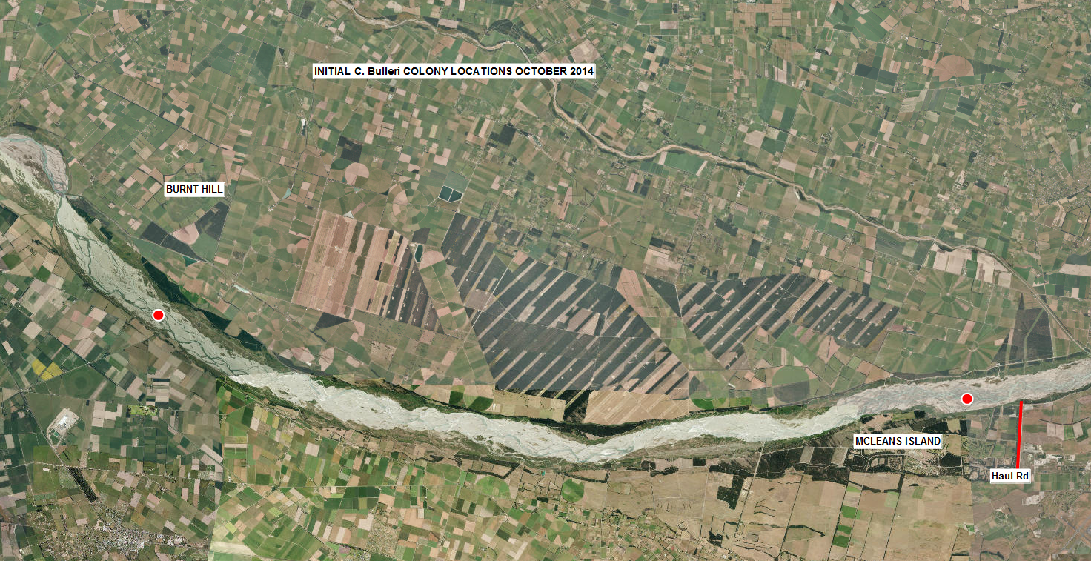
Figure 1: October 2014 Black-billed Gull failed early colony sites

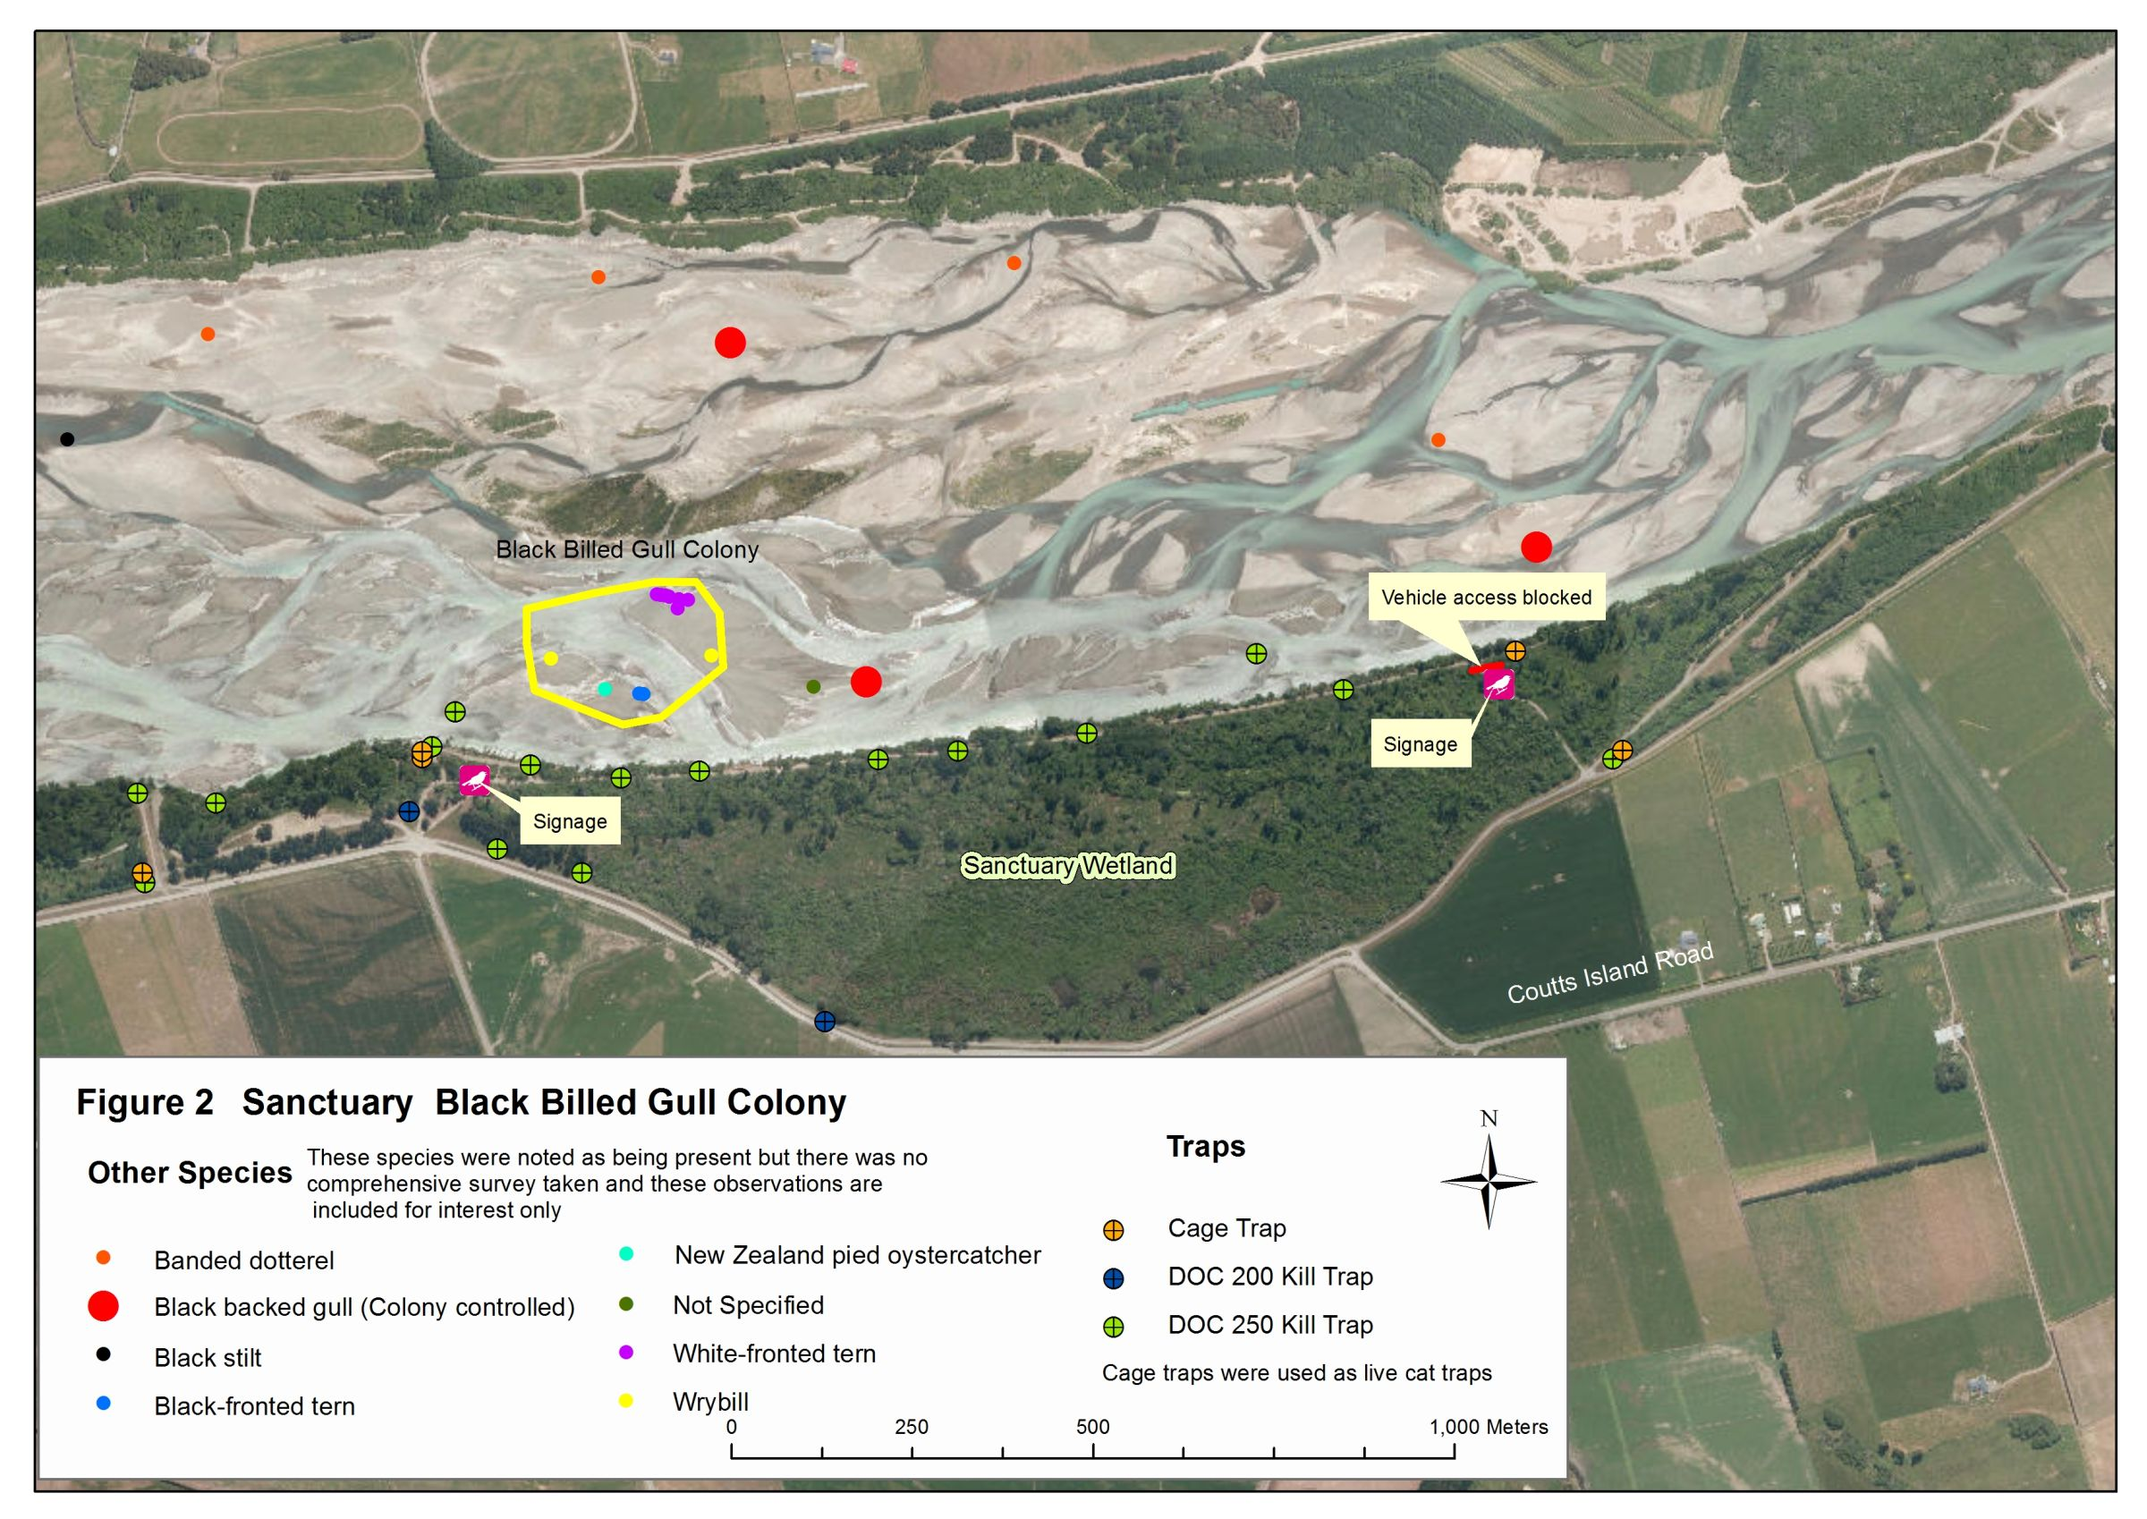
Figure 2: Black-billed gull colony and other observed bird species near Sanctuary Wetland during 2014-2015 breeding season
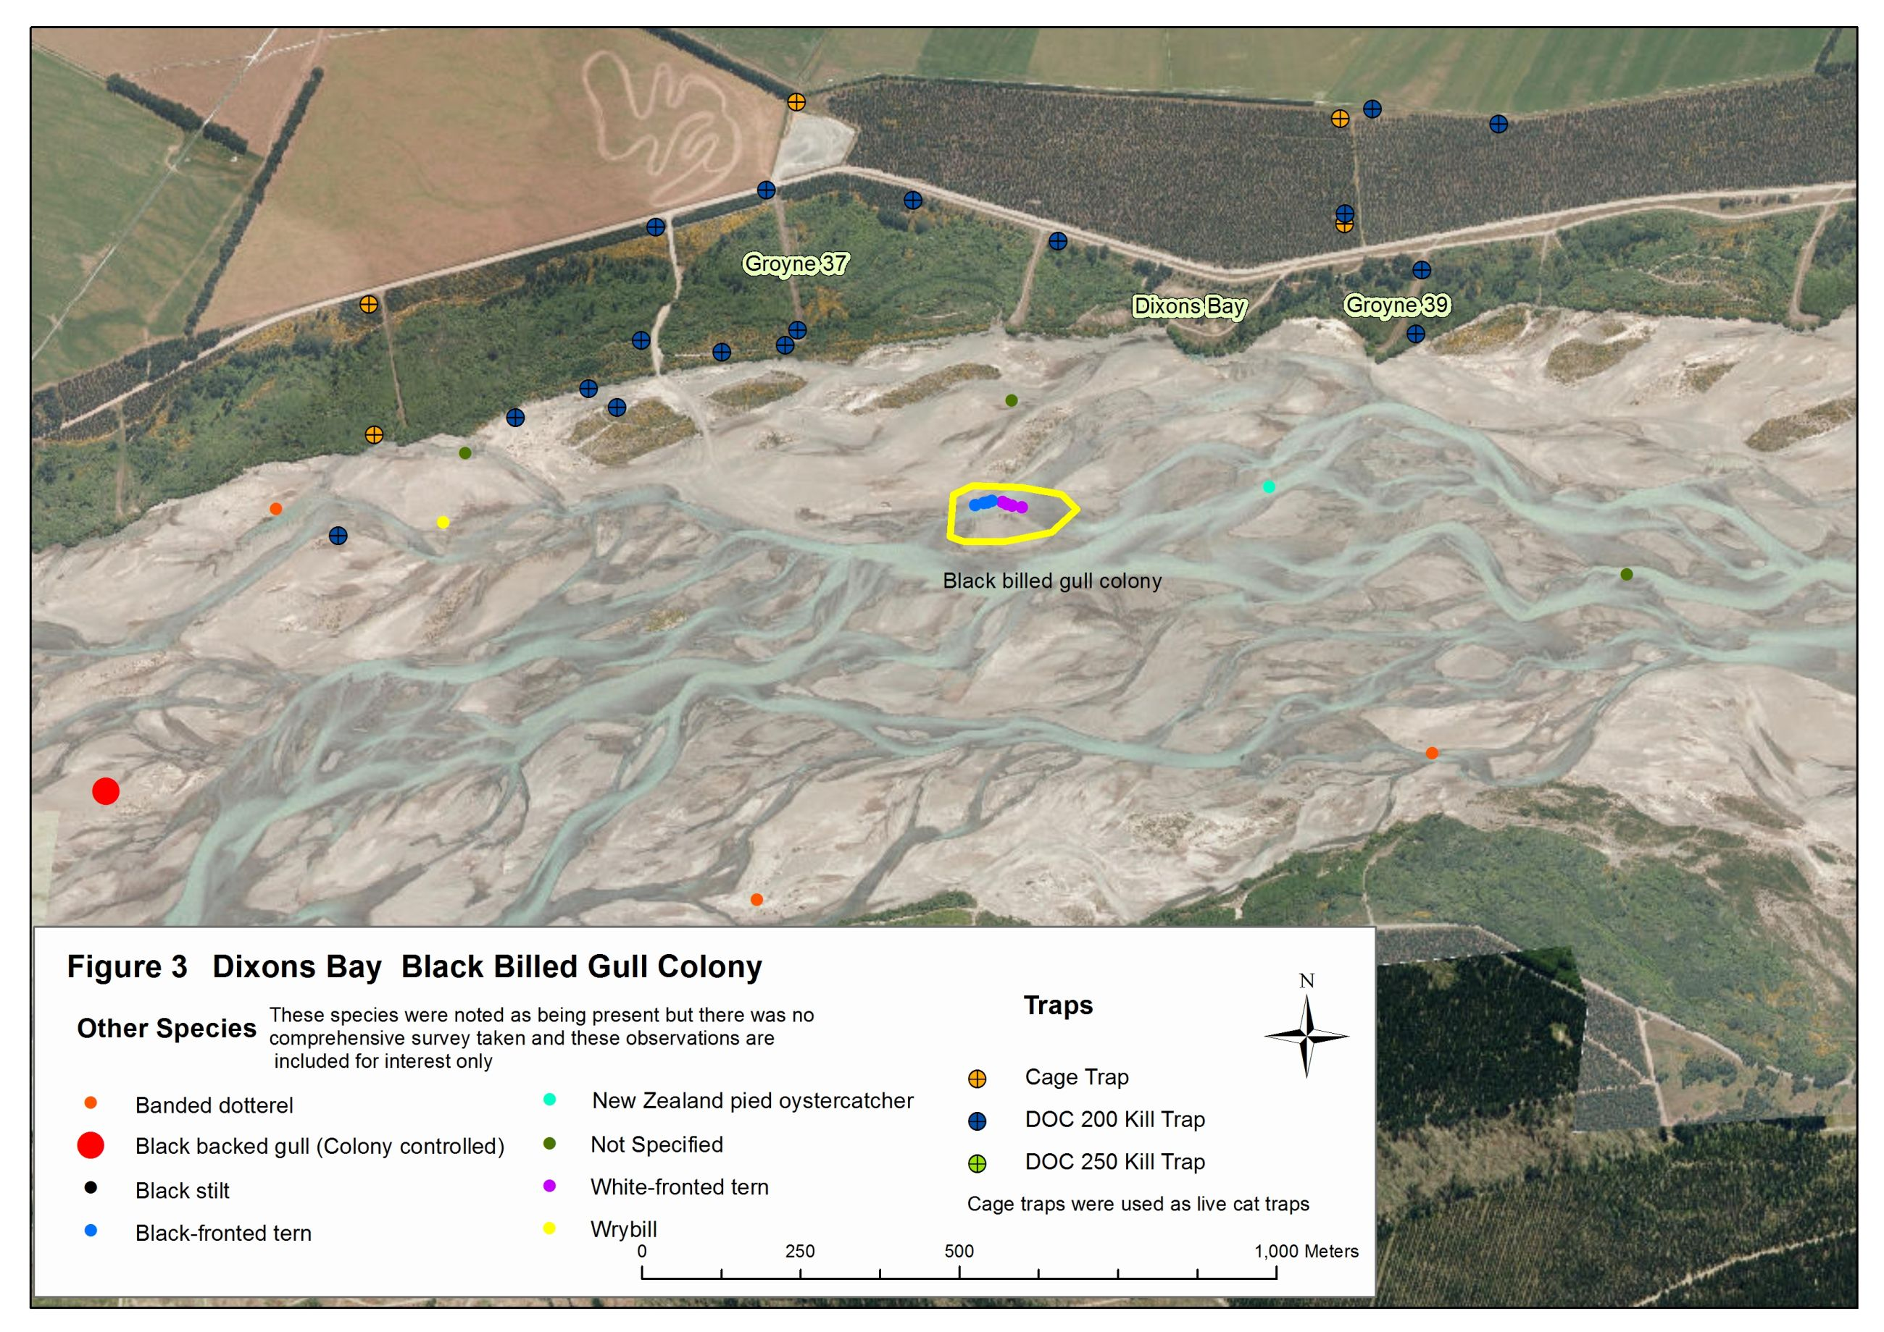
Figure 3: Black-billed gull colony and other observed bird species near Dixons Bay during 2014-2015 breeding season
Appendix 2
Pre-Season Technical Advisory Meeting Minutes

Waimakariri River Regional Park braided river birds 2014-2015 pre-season meeting to discuss operational management options for the upcoming season.

Monday 25th August 2014, 2pm – 4pm
Kainga Parks Office (1330 Main North Road, Kainga)

Present: Courtney Thompson (Ecan), David Owen (Ecan), Phillip Cochrane (Ecan), Frances Schmechel (Ecan), Niall Mugan (Keystone Ecology), Andrew Crossland (CCC).

Budget: Phil (Land resources) $10,000 (possibly more if needed)
David Owen (Parks) $7,000
Frances (biodiversity) Liaison with Regional Initiatives Fund committee, who may fund research and other initiatives in the lower Waimakariri, although this will be managed separately to basic Parks Team operational bird assistance.
Ecan staff time is in addition to the funding outlined above. Parks staff will cover a variety of roles supporting the work of the contractor engaged for monitoring and pest control.

CCC have SES projects (Special Ecological Sites) and have an interest in the area between Harewood Crossbank and Weedons Ross Road – potential future monetary support. CCC may be able to offer non-monetary support in the interim, e.g. survey assistance.

Target Species:
Primary focus is Black-billed gulls again this year, with expected flow on benefits for other species including black-fronted terns. Black-billed gulls have been downgraded to nationally critical.

Available Information:
A real benefit seen in increasing push of information to school kids. Courtney to talk to Ecan education team. Project River Recovery has already created a good resource and posters, which we may be able to distribute in conjunction with any schools we contact. Niall also suggested a possible mascot/costume that could accompany talks with younger schools to make the presentations more memorable.
“Birds of the Waimakariri” on Youtube and Vimeo also available to distribute again this season.
A Braided River specific website is currently being created and more information on this should be released shortly.
Andrew suggested a contact he has at TV1 that is interested in river/ranger type stories – could be investigated as a possible way of getting publicity for birds.
The large blank pillars under the motorway bridge could be a great place for a graffiti artist to paint murals of the braided river birds to increase public awareness – Courtney to investigate.
Niall suggested a possible brochure drop to the Chch airport for their waiting lounge?

Information with key stake holders:
We need to make sure we release the right information to:
Gravel extractors,
4WD clubs
Jet Boat Clubs
Fish and Game (license holders)

Last year an Ecan Ranger spoke to various machinery operators in their smoko rooms about what to look out for when working in the Waimakariri – plenty of value seen in this and will be pushed again this year. Rangers could increase interaction with machinery operators out in the field if possible.
A suggestion was made of bird stickers that could be handed out to various excavation companies to go in the windows of vehicles that would be working in the river.

Pest Control:
Although we don’t know the scale of how much mammalian predator trapping helps nesting birds in the Waimakariri, it was generally agreed that it definitely wouldn’t have a negative impact so should continue.
This year cat traps will be tested by the contractor as well as regular mammalian predator trapping.
An extensive predator monitoring programme would be lengthy and expesive ($20k+).
Black Backed Gulls (BBG) continue to be perceived as a main threat to Black-billed gulls, although we are still unable to quantify the actual impact. Niall believes the impact to be more from habitat displacement.
CIAL continues to fund BBG control at the Waimakariri River, and have started this early this year (despite advise from Niall to wait a little longer until the BBG begin to form colonies).
Last year CIAL had a general river-wide target of reducing BBG control, while Ecan funding went more towards controlling BBG colonies either side of Black-billed gull colonies. Niall will take this approach again this year.
The group unanimously agreed that this control of BBG’s is still justified.
Potential harrier control was discussed for some time. It was agreed that harriers would predate black-billed gulls and that control of specific nuisance birds could be justified, but actual control would be very difficult. Harrier control is not likely to be a predator control option for the Parks team this season.

Research Opportunities:
Although not a specific goal of the Parks team, the lower Waimakariri may receive some research funding from the Regional Initiatives Fund that Frances is involved with. Any research would be of great benefit to the management currently undertaken by Parks. Research in to flooding frequency and serverity could be useful, although some question if this is actually relevant when the birds have already evolved to cope with this. Frances has created a graph already showing flooding events over a period of years and how those events impacted breeding viability.
Some other research topics discussed by the group were:
Viability of off-river habitat creation,
Importance of various predators in the Waimakariri (including Avian),
Optimal Island height and size.

Within the scope of the Parks Team work, there need to be definite measures of productivity and outcomes that will be agreed with and measured by the Contractor this season.

Habitat Management:
Park Rangers should keep an eye on gravel extractors and river engineers so that rangers can tell if the extractor or engineering works are causing river changes that might impact the birds. Park Rangers are the main point of contact with people out in the riverbed so should push information out where possible, including keeping in touch with machinery operators, general public, fishermen, dog walkers etc.
This year Parks would like to try waiting until after a large fresh, then going out (flight?) to ID possible suitable river island habitats left over after that fresh event. Decoys could be trialled in an attempt to attract the Black-billed gulls to the more preferable island habitats. Andrew has a contact to good quality decoys – Courtney to liaise with Andrew on this.
There was some discussion around volunteer involvement in the bird protection; there have been issues in the past with actual work options that volunteers could be involved with at the Waimakariri, but if we go with trying to attract birds to a specific river island, vegetation clearing on that island could be a work option for volunteers.
Parks could discuss with the Consents section the option of applying for a consent for scrub clearing or water diversion should a small channel be needed to separate a colony from the river bank. Parks should also try to liaise closely with the Compliance section.

Action Points:

Courtney
- Contact Ecan Education Team to discuss possible schools to contact and putting together a presentation pack,
  - Timeframe: Make contact within a week of this meeting
- Investigate bird artwork for motorway pillars,
  - Timeframe: Contact NZTA/OPUS by end of September, have an answer on go-ahead by Xmas.
- Investigate bird sticker creation, cost and distribution,
  - Timeframe: by end of September.

David
- Finalise contract with Niall, including potential increase in contract river hours, by 5th August (liaise with Phil).
- Signage review with Courtney, ASAP. Check quantity and quality of signage (signs shaped like birds?).
- Ensure a Ranger (Quentin?) again speaks to machinery operators.

Frances
- To provide guidance on Black-backed gull control required above Henderson’s Road , on-going.
- Keep Parks team in the loop on Regional Initiatives Programme outcomes and research topics.

Appendix 3
Raw Trap Data from 2014-2015 Season:
TRAPID | DATE INSTALLED | DATE REMOVED | TYPE | COMMENTS
22 | 13/12/2012 | 13/12/2012 | DOC 150 Kill Trap | NULL
31 | 28/10/2014 | 6/01/2015 | DOC 250 Kill Trap | NULL
30 | 28/10/2014 | 6/01/2015 | DOC 250 Kill Trap | Stoat 6/11/14. 20/11/14 rat. 23/12/14 rat
26 | 28/10/2014 | 6/01/2015 | DOC 250 Kill Trap | 6/1/15 song thrush ?
29 | 28/10/2014 | 6/01/2015 | DOC 250 Kill Trap | Rat 6/1/15
25 | 28/10/2014 | 6/01/2015 | DOC 250 Kill Trap | Reinstated on the 6/11/14
23 | 28/10/2014 | 6/01/2015 | DOC 250 Kill Trap | NULL
24 | 28/10/2014 | 6/01/2015 | DOC 250 Kill Trap | NULL
28 | 28/10/2014 | 6/01/2015 | DOC 250 Kill Trap | Ferret 6/11/14. Hedgehog 23/12/14
32 | 29/10/2014 | 6/01/2015 | DOC 250 Kill Trap | Mouse 27/11/14
27 | 29/10/2014 | 6/01/2015 | DOC 250 Kill Trap | 23/12/14 hedgehog
33 | 29/10/2014 | 6/01/2015 | DOC 250 Kill Trap | NULL
34 | 29/10/2014 | 6/01/2015 | DOC 250 Kill Trap | Stoat 6/11/14. Rat 15/12/14
37 | 6/11/2014 | 6/01/2015 | DOC 250 Kill Trap | Hedgehog 13/11/14. Hedgehog 27/11/14. Hedgehog 13/12/14. Hedgehog 15/12/14. Hedgehog 23/12/14
47 | 6/11/2014 | 6/01/2015 | DOC 250 Kill Trap | 8/12/14 hedgehog.6/1/15 hedgehog
43 | 6/11/2014 | 6/01/2015 | DOC 250 Kill Trap | Hedgehog 13/11/14 . Hedgehog 6/1/15
36 | 6/11/2014 | 6/01/2015 | DOC 250 Kill Trap | Hedgehog 8/12/14.15/12/14 hedgehog
48 | 7/11/2014 | 19/11/2014 | DOC 200 Kill Trap | Trap destroyed by river engineering
44 | 7/11/2014 | 29/01/2015 | DOC 200 Kill Trap | Hedgehog 14/11/14. 20/11/14 hedgehog. 30/12/14 hedgehog
39 | 7/11/2014 | 29/01/2015 | DOC 200 Kill Trap | 29/1/15 rat
46 | 7/11/2014 | 29/01/2015 | DOC 200 Kill Trap | Hedgehog 14/11/14
38 | 7/11/2014 | 29/01/2015 | DOC 200 Kill Trap | NULL
45 | 7/11/2014 | 29/01/2015 | DOC 200 Kill Trap | NULL
35 | 7/11/2014 | 29/01/2015 | DOC 200 Kill Trap | Hedgehog 14/11/14. Hedgehog 15/12/14. Hedgehog 20/1/15. Hedgehog 29/1/15
41 | 7/11/2014 | 29/01/2015 | DOC 200 Kill Trap | Stoat 27/11/14. Stoat 21/1/15
42 | 7/11/2014 |  | DOC 200 Kill Trap | 20/11/14 hedgehog.27/11/14 hedgehog
49 | 7/11/2014 |  | DOC 200 Kill Trap | Hedgehog 14/11/14. Hedgehog 20/11/14
50 | 7/11/2014 | 29/01/2015 | DOC 200 Kill Trap | Hedgehog 13/1/15
40 | 7/11/2014 | 29/01/2015 | DOC 200 Kill Trap | 20/11/14 stoat. 3/12/14 stoat. 12/12/14 hedgehog.23/12/14 hedgehog. Rat 13/1/15. Hedgehog 29/1/15
51 | 13/11/2014 | 6/01/2015 | DOC 200 Kill Trap | NULL
52 | 20/11/2014 | 6/01/2015 | DOC 200 Kill Trap | Ferret 6/1/15
66 | 2/12/2014 | 15/12/2014 | Cage Trap | NULL
62 | 2/12/2014 | 29/01/2015 | DOC 200 Kill Trap | NULL
53 | 2/12/2014 | 29/01/2015 | DOC 200 Kill Trap | 23/12/14 hedgehog. Hedgehog 29/1/15
61 | 7/12/2014 | 15/12/2014 | Cage Trap | Possum 15/12/14
60 | 7/12/2014 | 15/12/2014 | Cage Trap | NULL
56 | 7/12/2014 | 15/12/2014 | Cage Trap | NULL
57 | 7/12/2014 | 15/12/2014 | Cage Trap | NULL
59 | 7/12/2014 | 15/12/2014 | Cage Trap | Hedgehog 15/12/14
55 | 8/12/2014 | 15/12/2014 | Cage Trap | NULL
58 | 8/12/2014 | 15/12/2014 | Cage Trap | NULL
63 | 8/12/2014 | 15/12/2014 | Cage Trap | NULL
54 | 8/12/2014 | 15/12/2014 | Cage Trap | NULL
67 | 11/12/2014 | 29/01/2015 | DOC 200 Kill Trap | NULL
64 | 11/12/2014 | 29/01/2015 | DOC 200 Kill Trap | NULL
65 | 11/12/2014 | 29/01/2015 | DOC 200 Kill Trap | 15/12/14 hedgehog . 29/1/15 hedgehog

Appendix 4
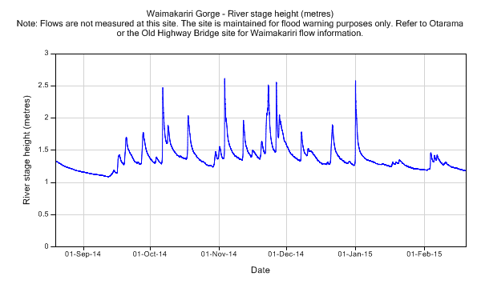
Figure 1: Graph showing river stage heights at the Waimakariri Gorge during the September 2014 to February 2015 braided river bird breeding season.

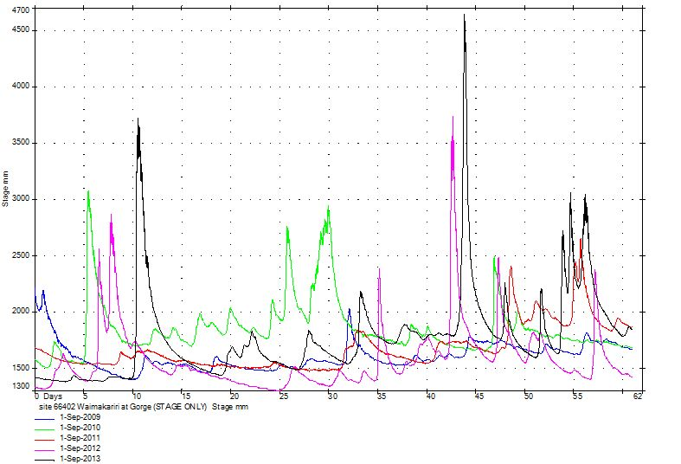
Figure 2: Water stage heights from September onwards at the Waimakariri Gorge compared between 2009 and 2013 inclusive. Significant peaks were recorded in both 2013 and 2012.

Appendix 5

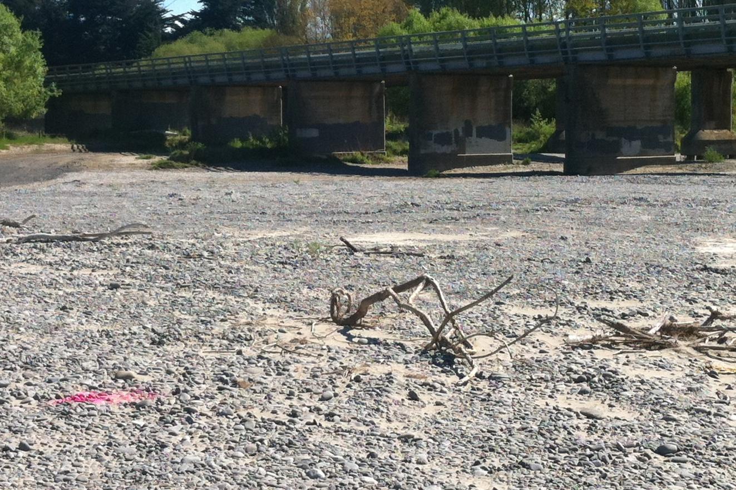

Figure 1: Banded Dotterel nesting between Motorway Bridge and Main North Road Bridge in a highly public area with only minimal sticks and rough ground for protection. Dotterel is right of the pink mark.

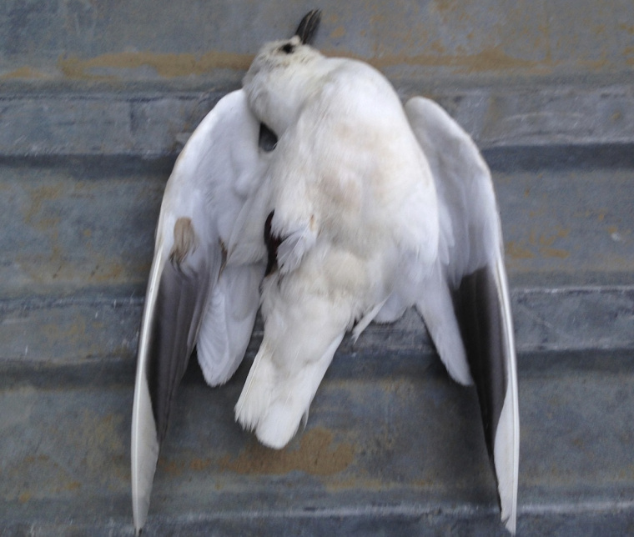

Figure 2: Juvenile Black-billed Gull found upstream from Dixons Bay colony, appears to have been shot
Appendix 6:

Bird Sticker Designs

